***Selenium Integration with Github and Jenkins for C# Visual Studio***

***Index:***

1. ***Create GitHub Account and Repository***
2. ***Deploy Visual studio project to GitHub repository***
3. ***Download Git.exe and install***
4. ***Path of msbuild.exe***
5. ***Download nuget.exe***
6. ***Path nunit-console.exe path***
7. ***Set up the Jenkins***

***Pre-Requisites for Jenkins:***

***1.GitHub Repository URLubHubHsdfgnm,gnsd,gnmsd***

***2.Git.Exe***

***3.MSBuild.exe***

***4.Nuget.exe***

***5.Nunit-console.exe***

***Create GitHub Account and Repository:***

***Step 1)*** Open Browser and enter URL = <https://github.com/> 🡪 click on SignUP

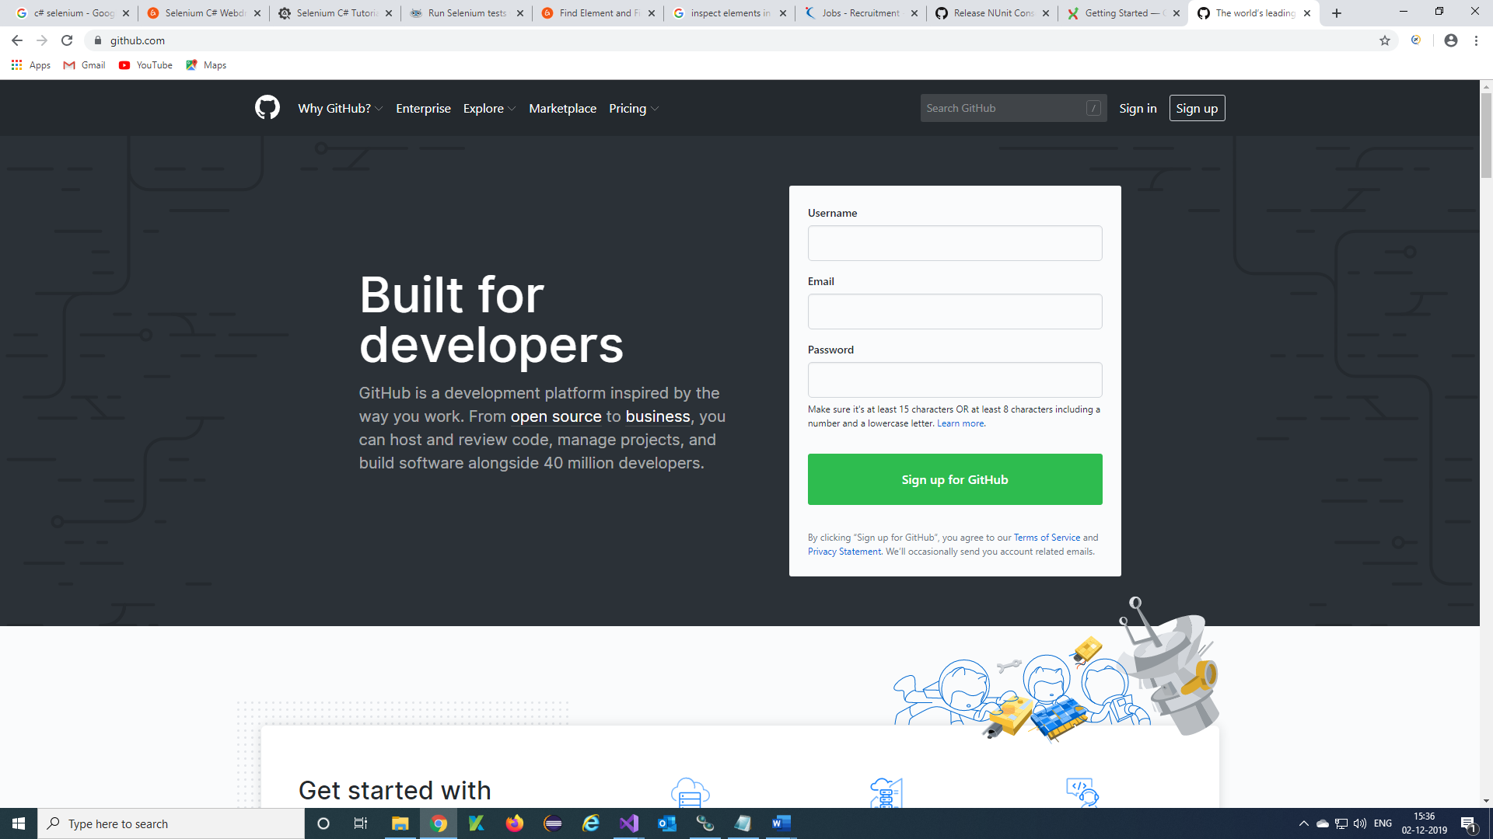

***Step 2)*** Enter Details and Verify 🡪 click on ‘Next a plan’

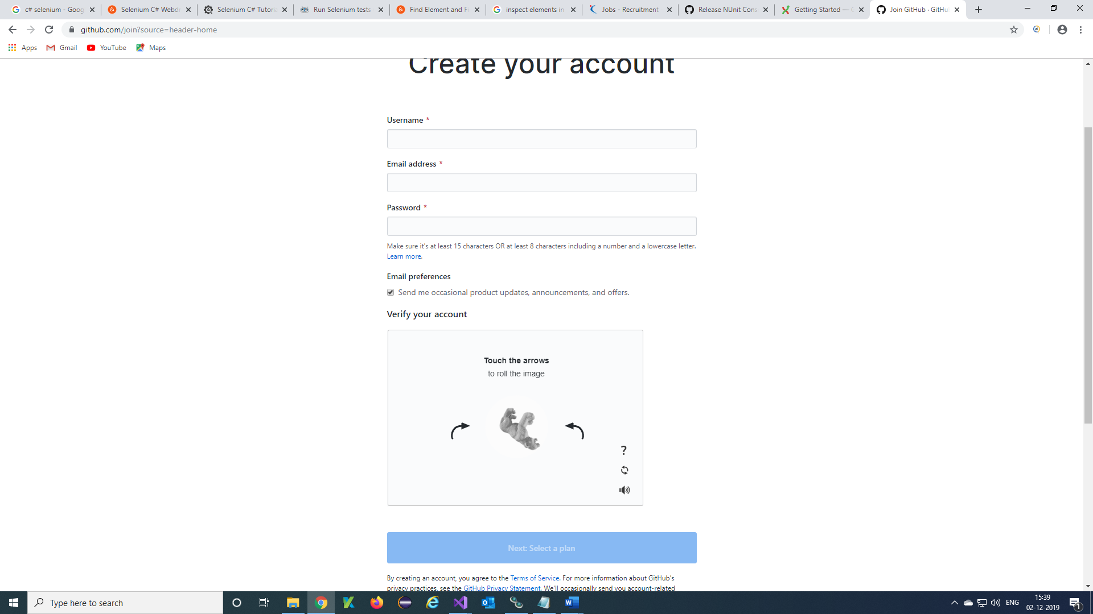

***Step 3)*** SignIn into your created account with your credentials

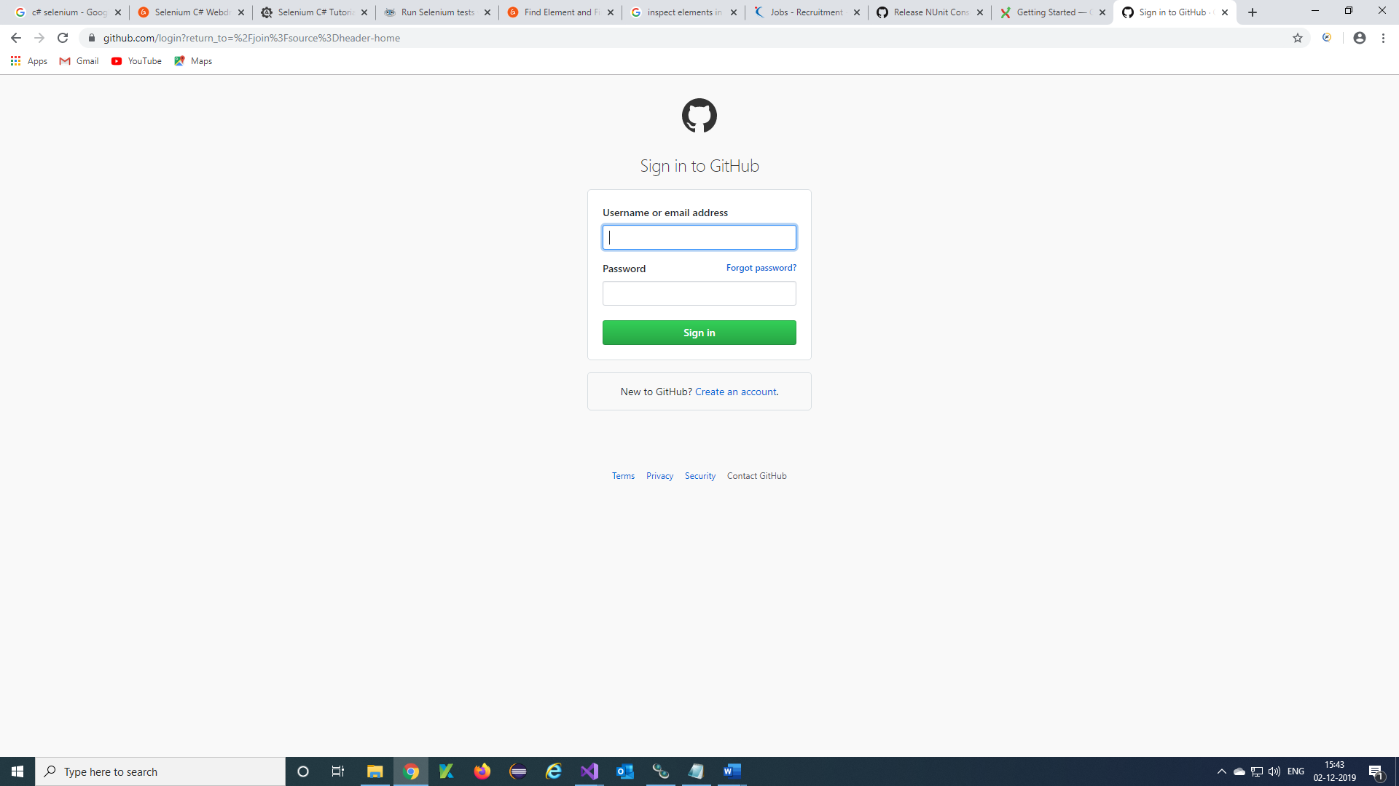

***Step 4)*** Your Account will be displayed 🡪 click on New

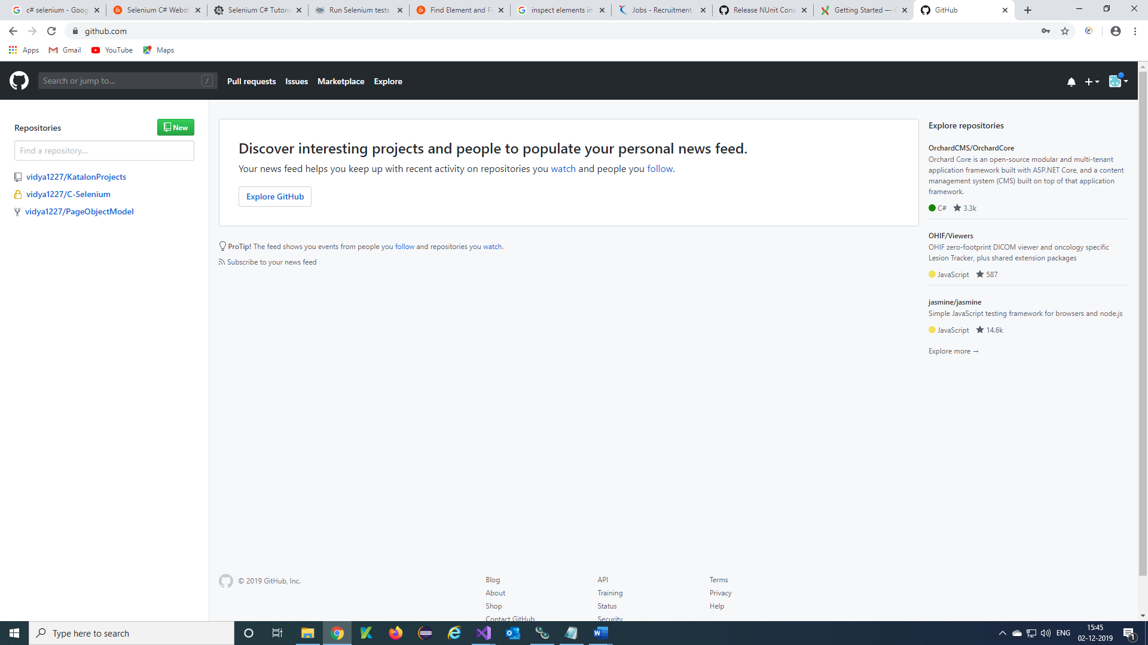

***Step 5)*** Create a new repository will display and Enter Repository name, Description, select the check boxand click on Create repository

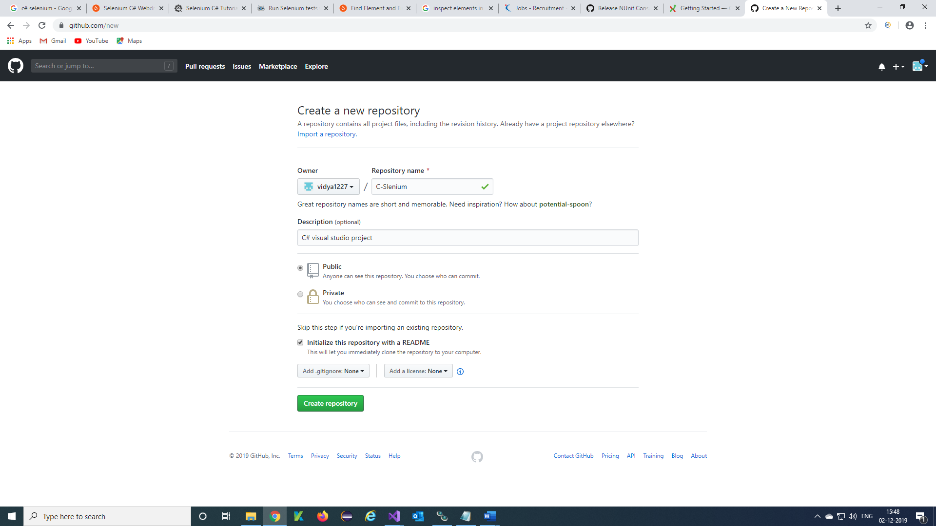

***Step 6)*** Your repository is created and displayed.

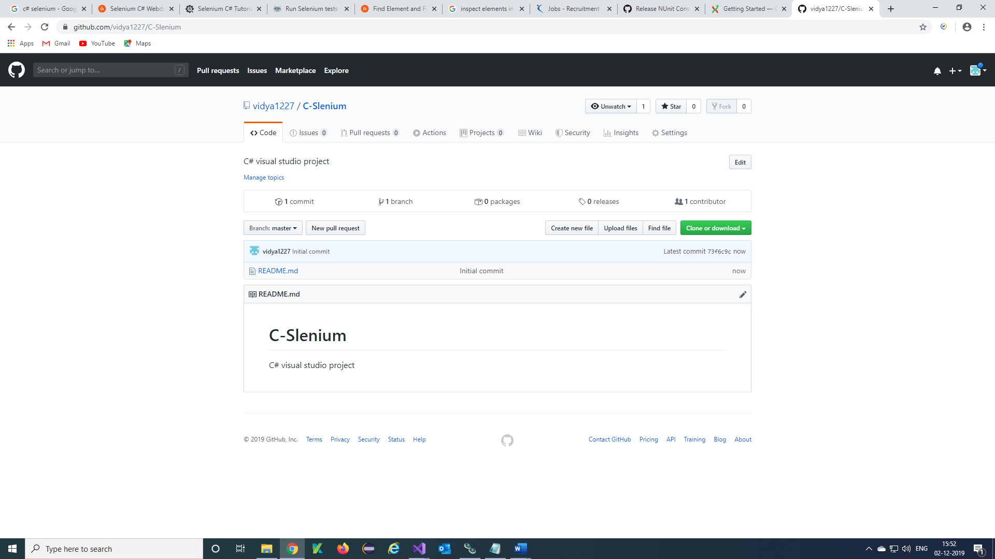

***Step 7)*** Click on Clone or download and copy the URL of repository

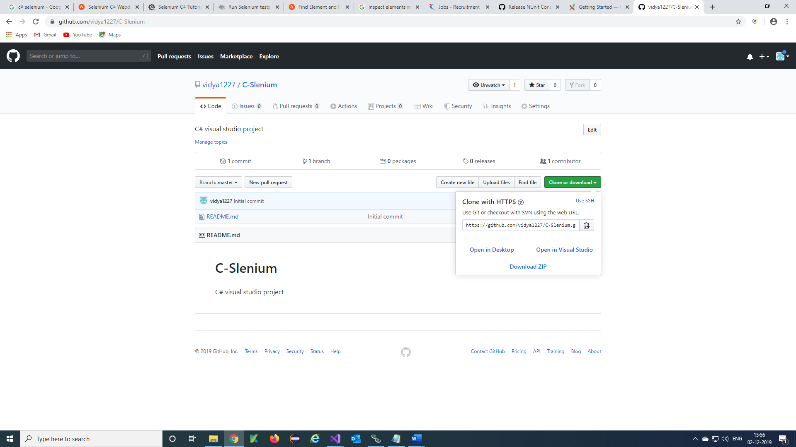

***Deploy Visual studio project to GitHub repository:***

***Step 1)*** Copy Git Repository URL from GitHub

***Step 2)*** Open Visual Studio project click on File 🡪 Add to Source Control

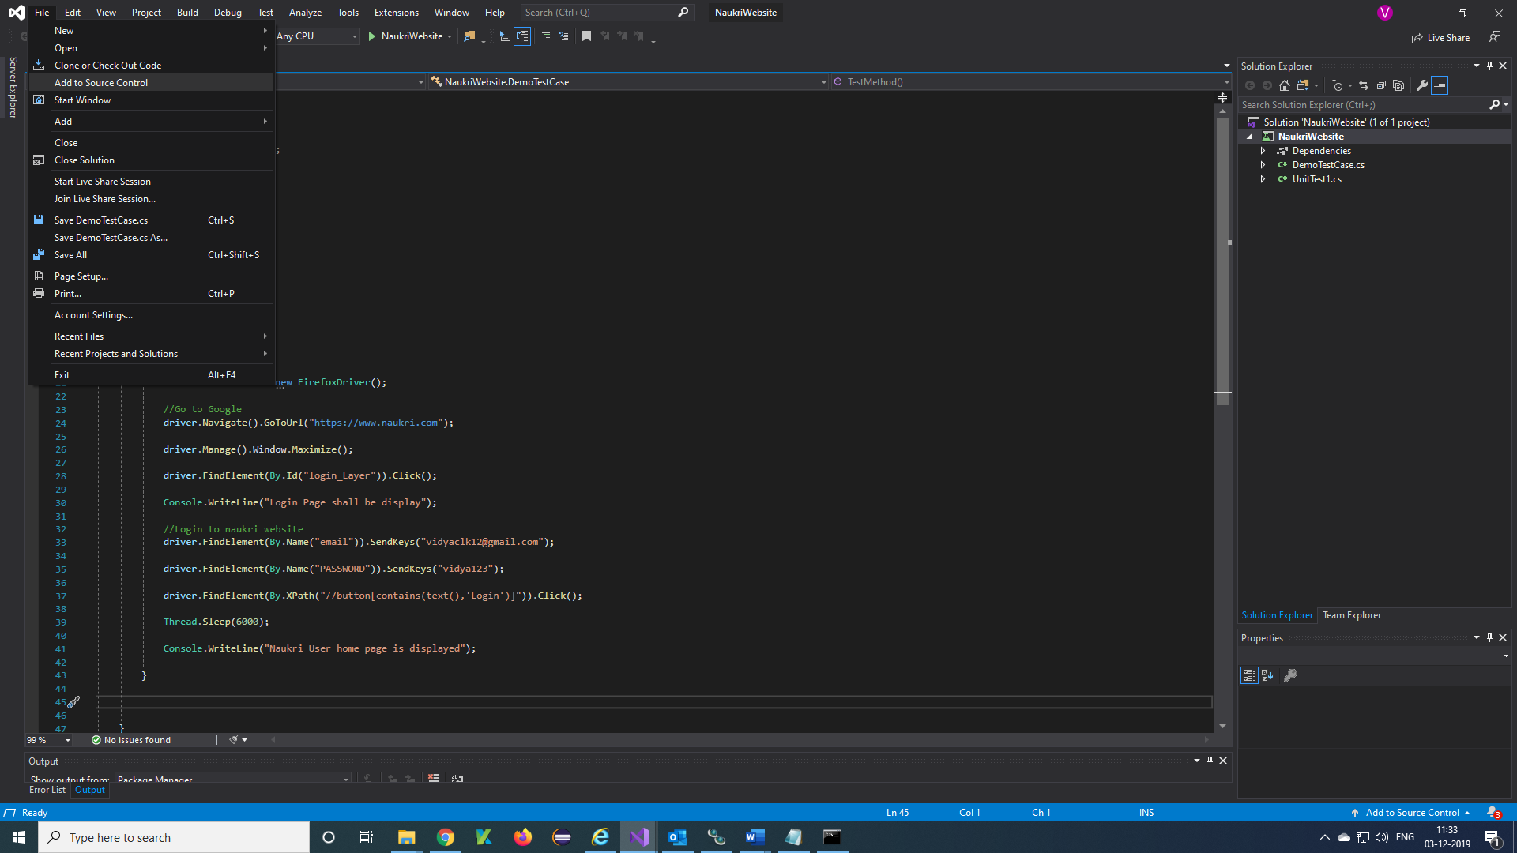

***Step 3)*** Click on Teat Explorer 🡪 Sync

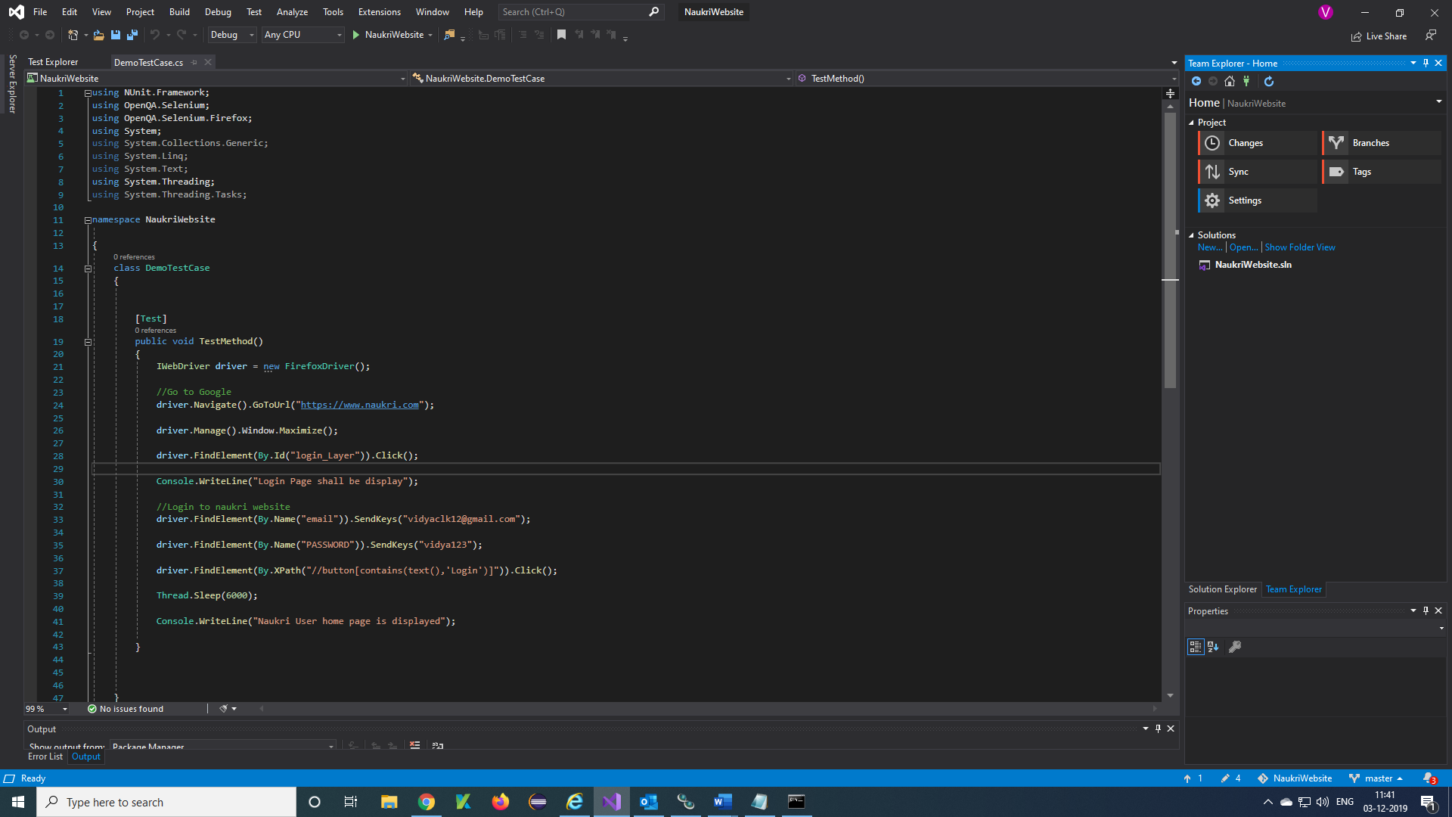

***Step 4)*** Click on Publish Git Repo

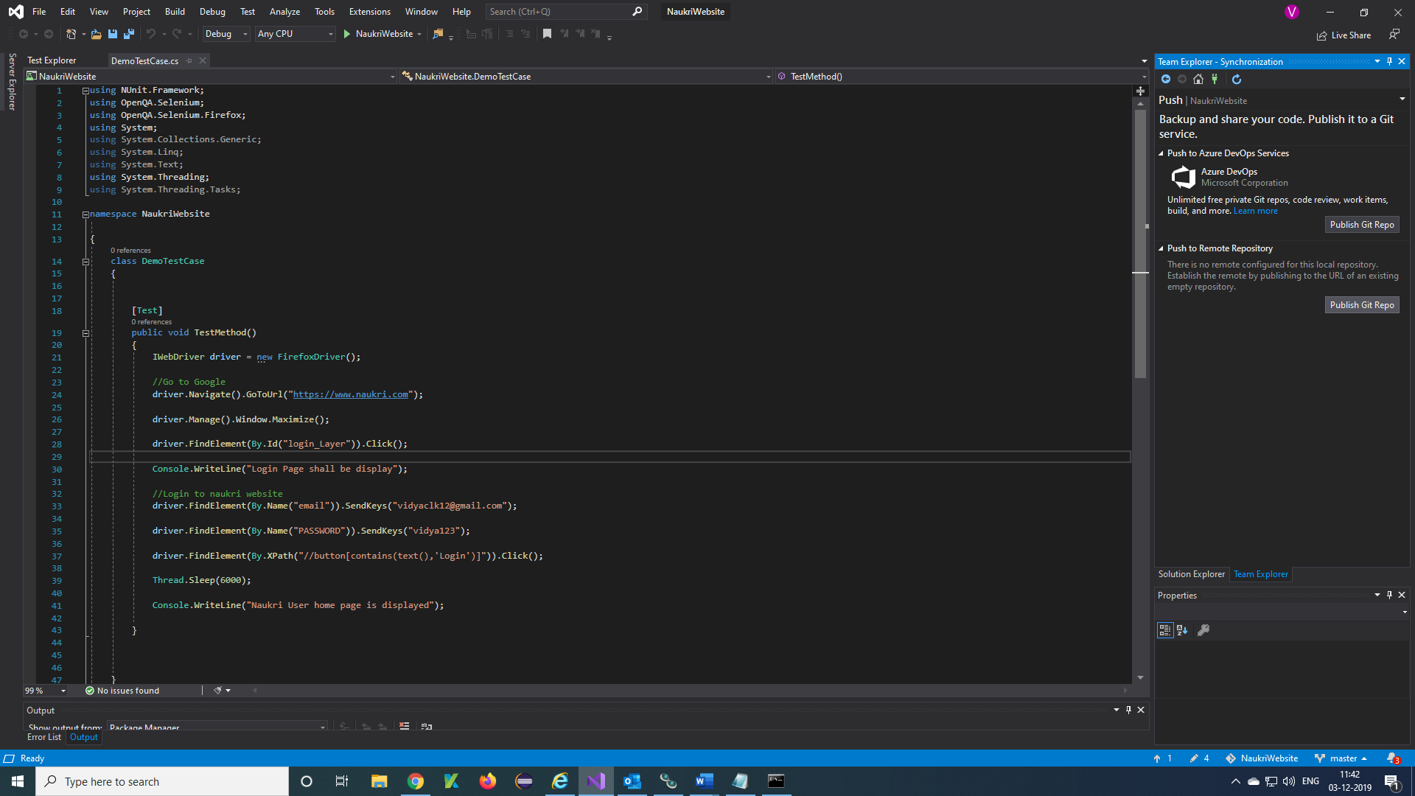

***Step 5)*** Enter GitHub Repository URL 🡪 Publish

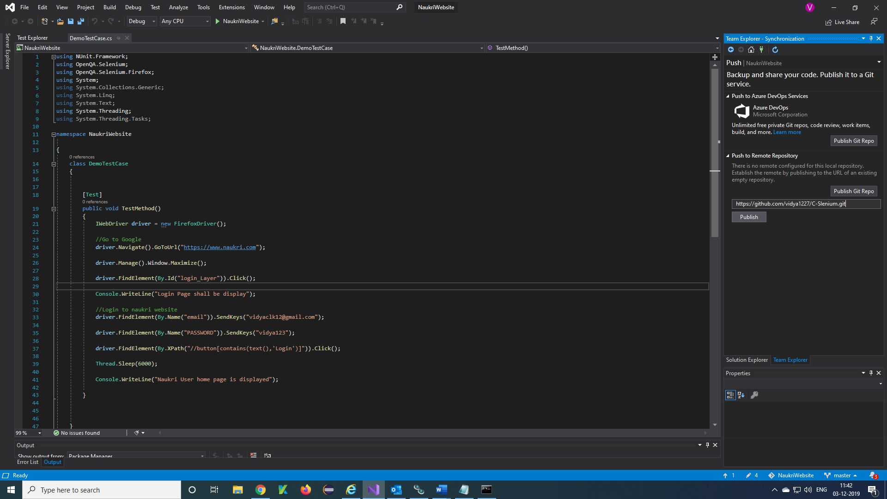

***Step 6)*** Click on File 🡪 Clone or Check Out Code

Enter the repository location and local path then click on GitHub

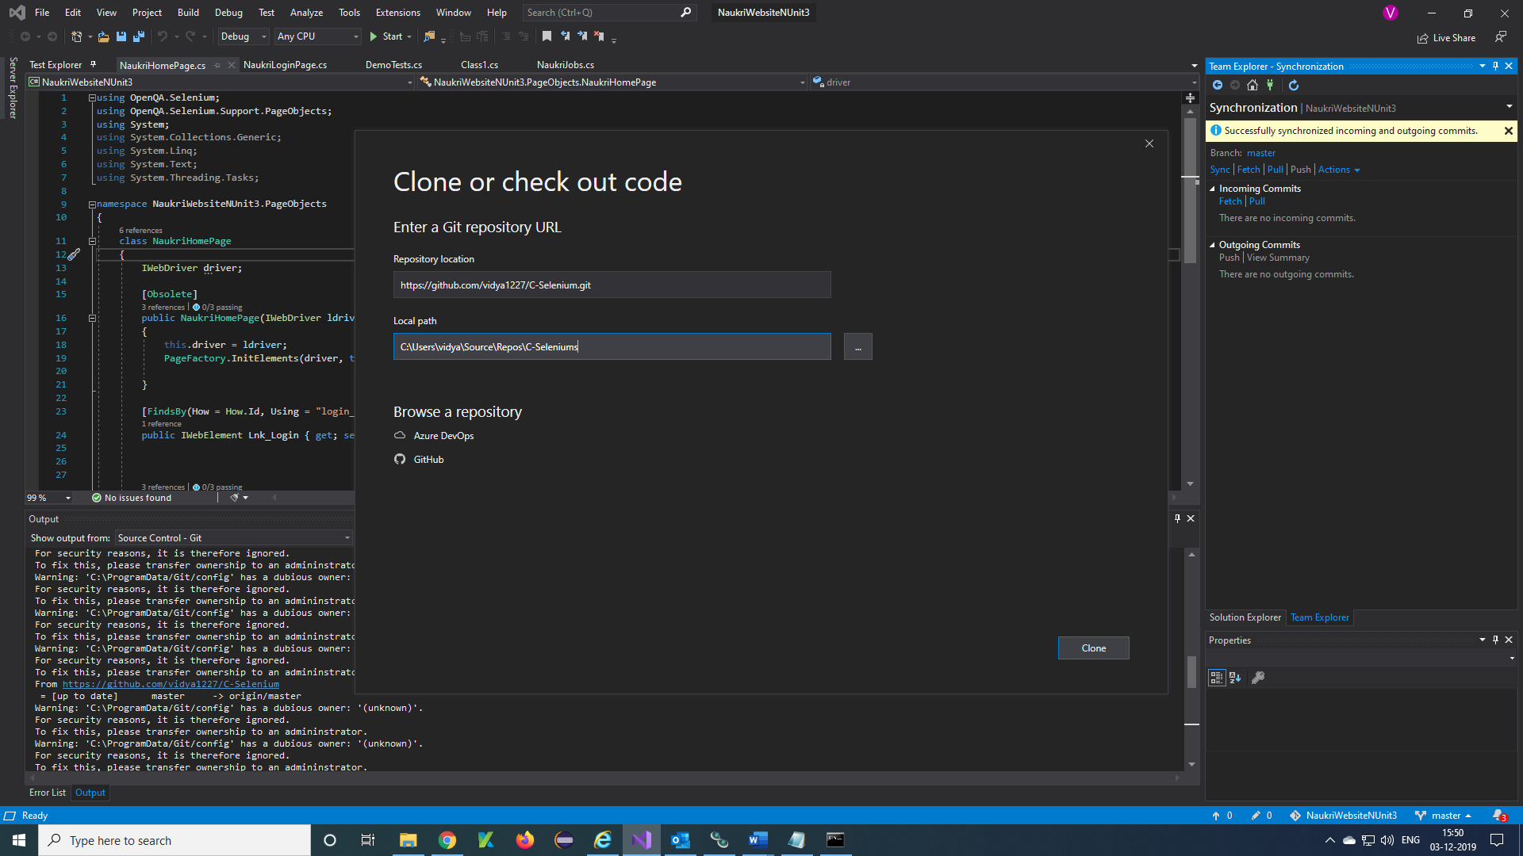

***Step 7)*** Enter GitHub UserName and password 🡪 Sign in

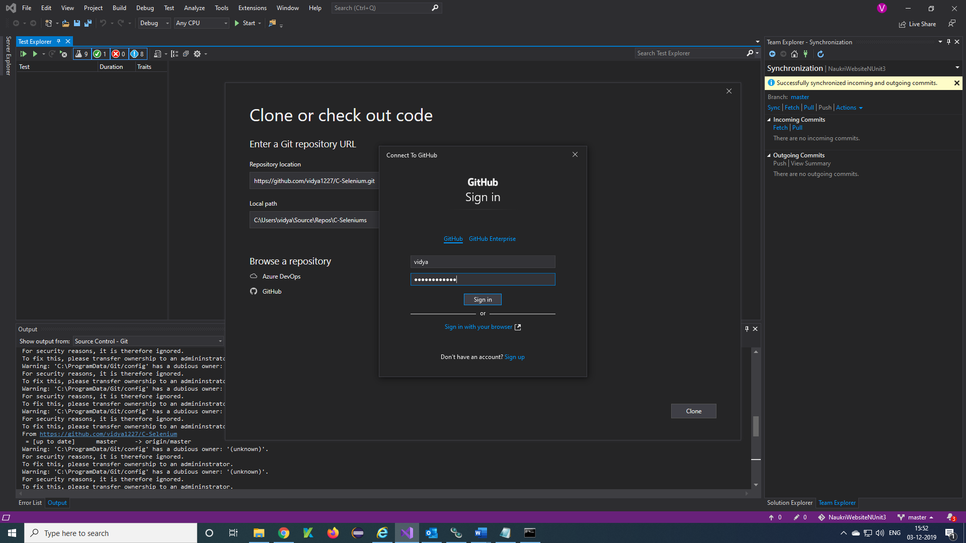

**Step 8)** Enter GitHib repository URL *=* <https://github.com/vidya1227/C-Selenium.git>

Browse Local path 🡪 Clone

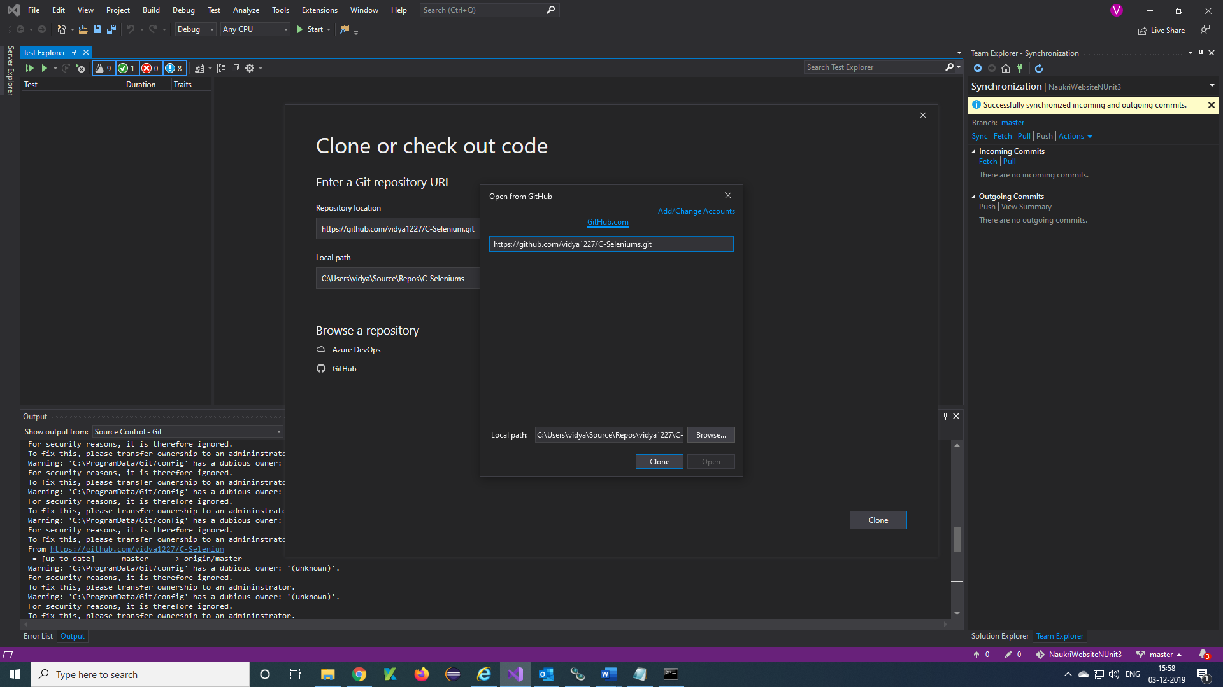

***Step 9)*** Click on Team Explorer 🡪 Changes 🡪 Enter commit message in text box 🡪 Commit All

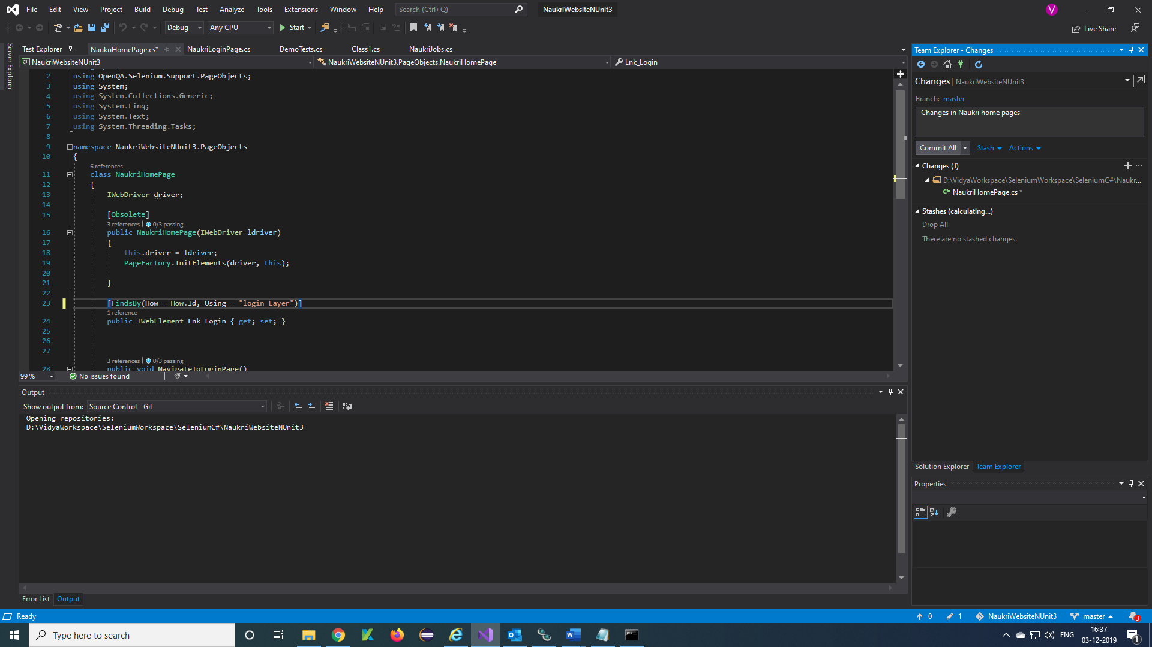

***Step 10)*** Click on Sync

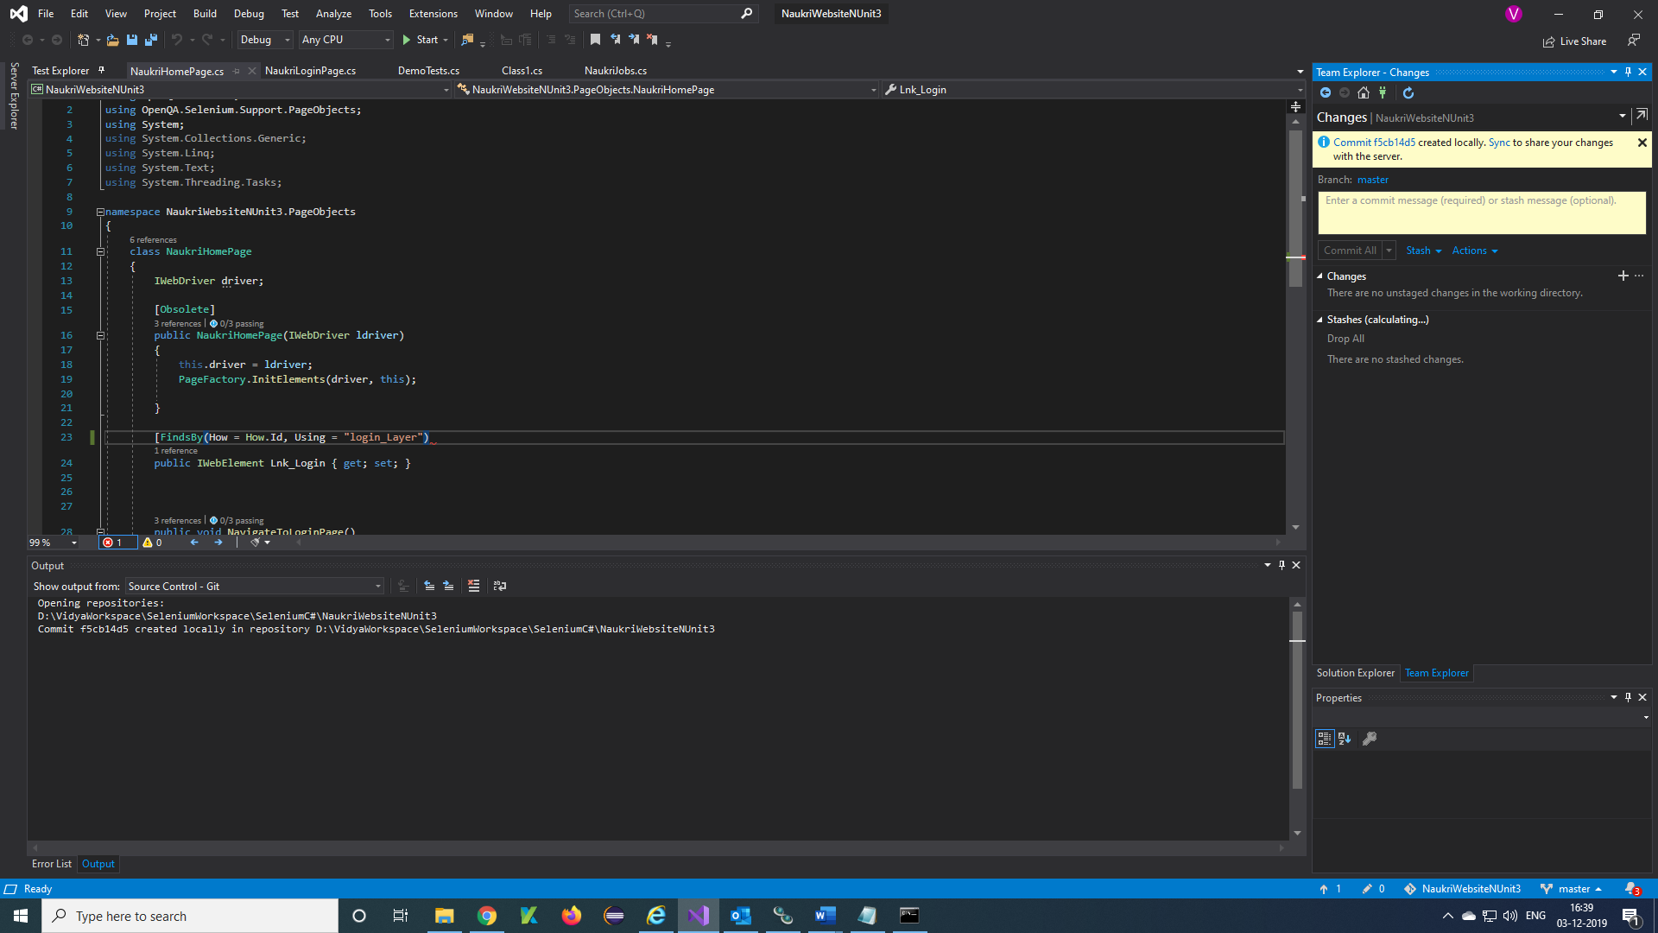

***Step 11)*** Click on Push

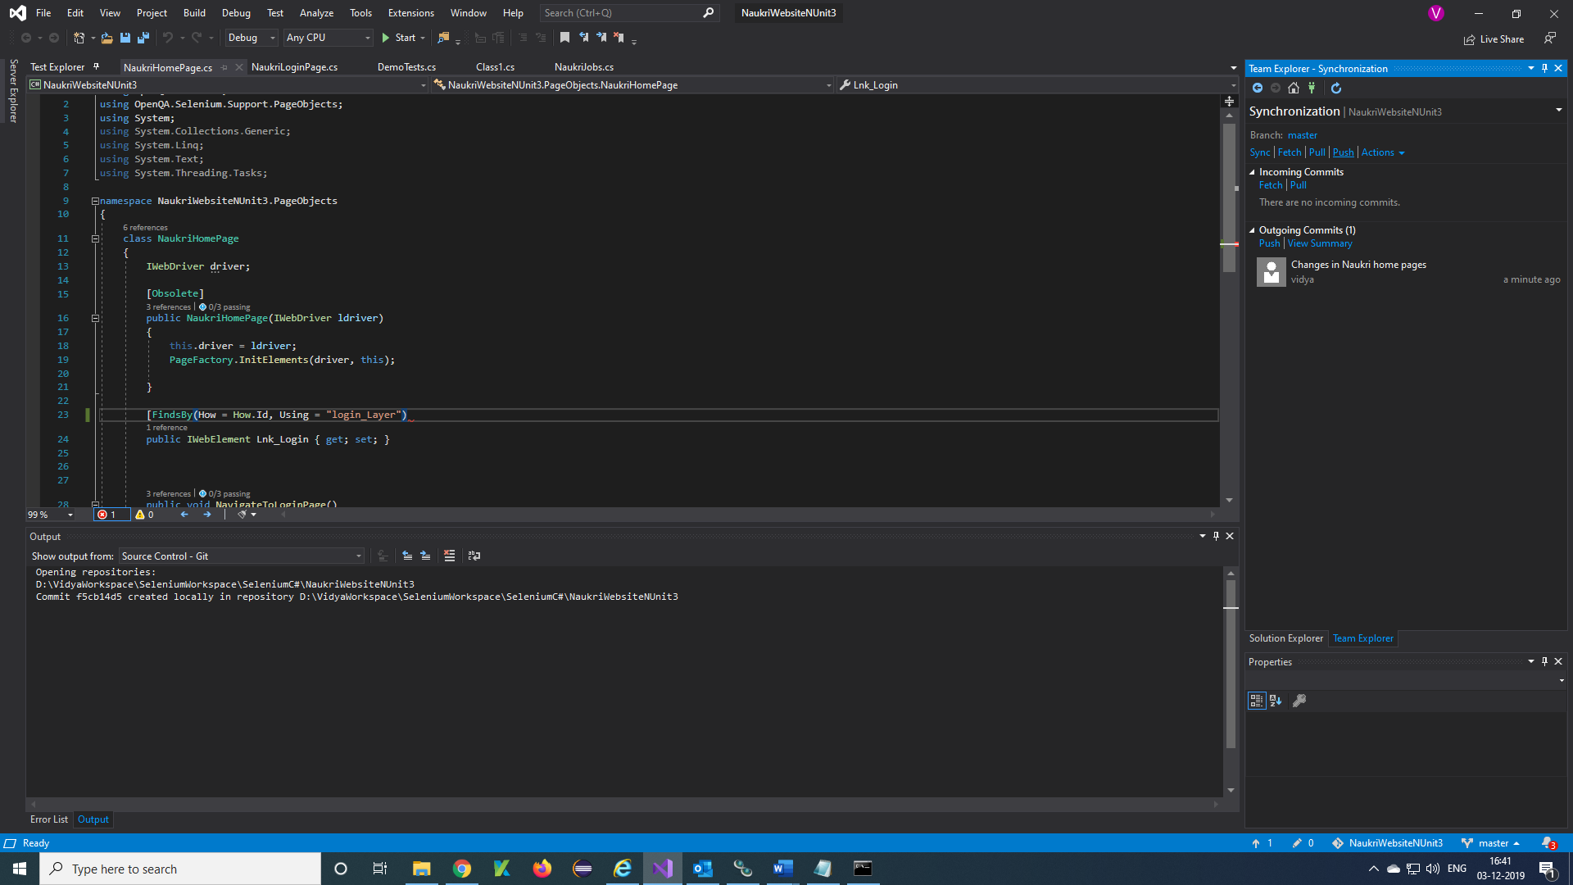

***Step 12)*** Files are pushing to git repository

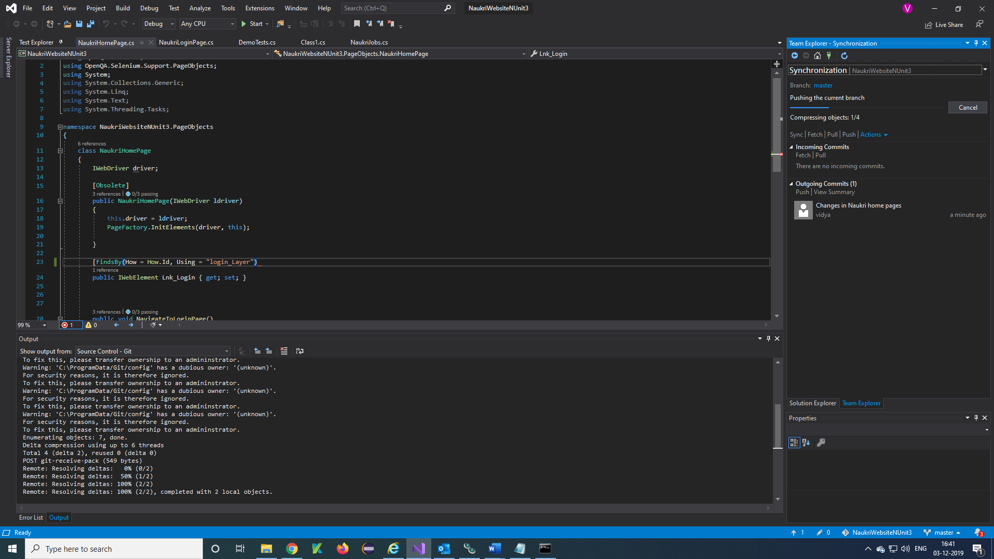

***Step 13)*** Click on Sync

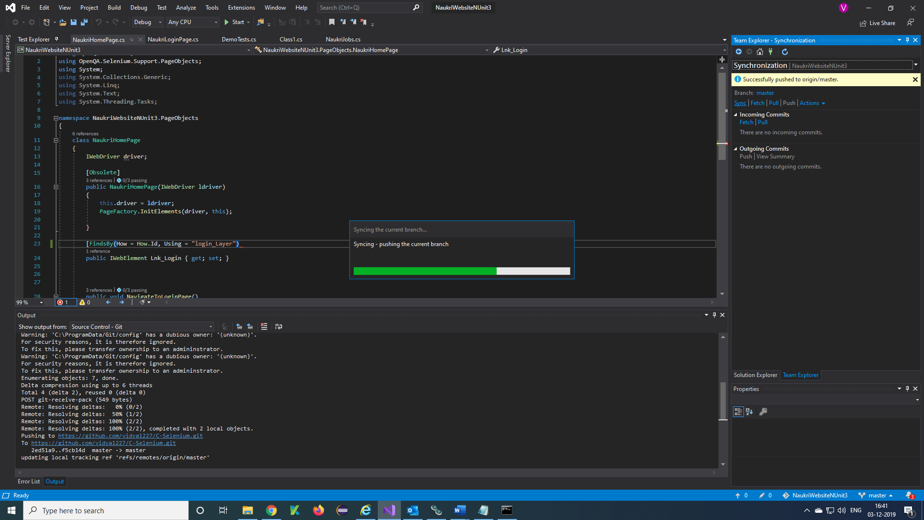

***Step 14)*** Your project will look like once after project is Successfully deployed to git repository

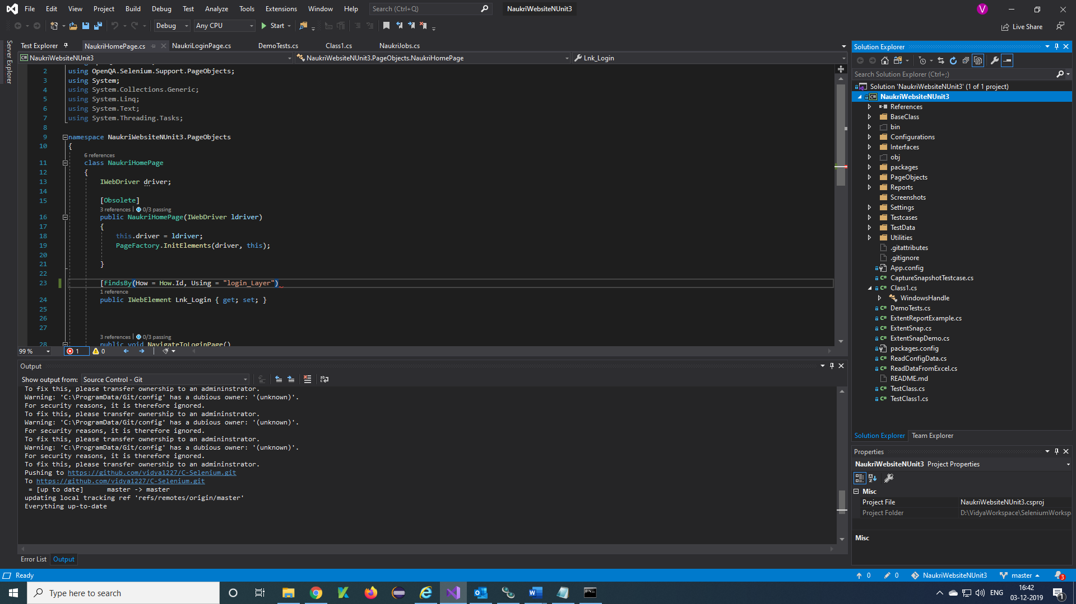

***Download Git and install:***

***Step 1)*** Download the git using the below link

<https://git-scm.com/downloads>

Click on Windows, git.exe will download.

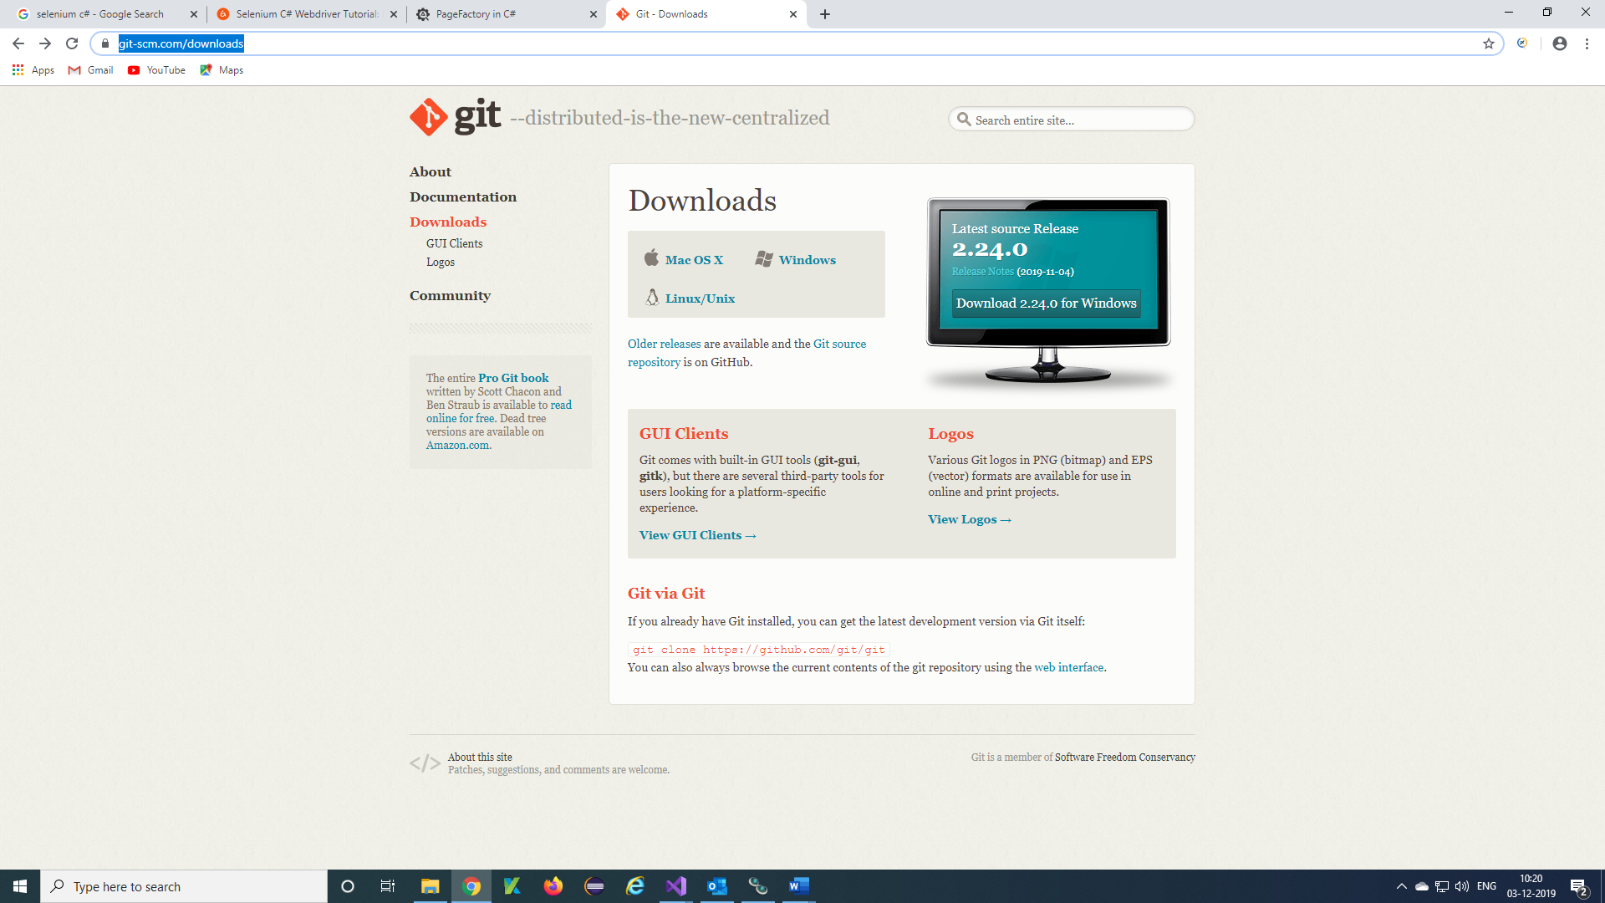

***Step 2)*** Once after downloaded install git exe in your PC

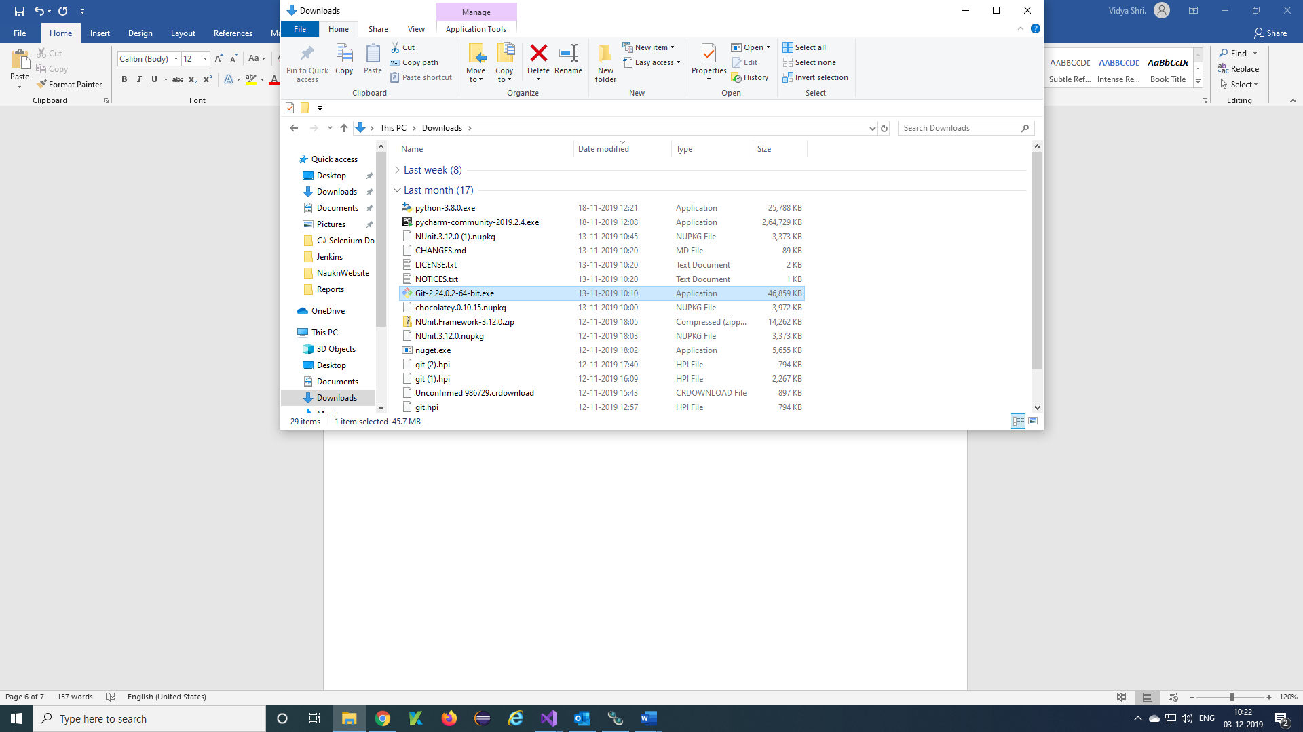

***Step 3)*** Once after Installation is done, you will get Git folder in your installation path

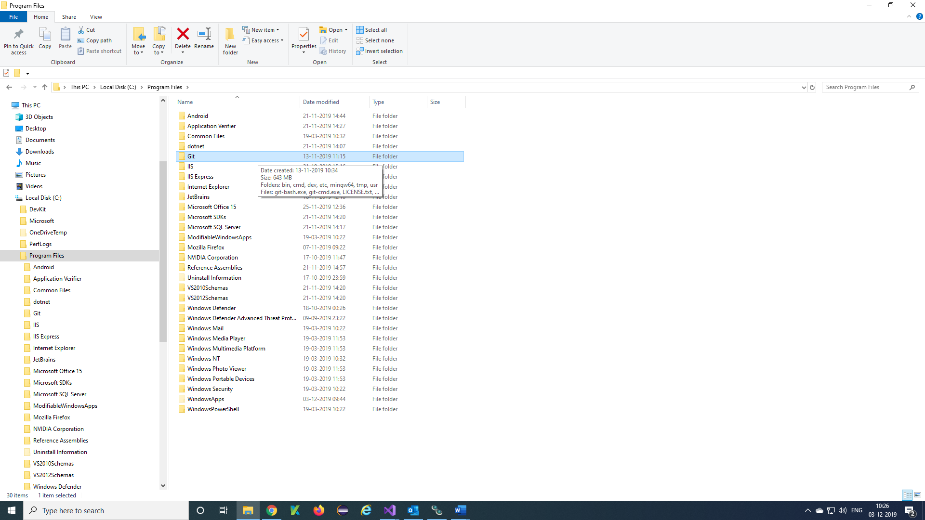

***Step 4)*** Open your bin folder in Git, we will get git.exe and copy the path of git.exe

"C:\Program Files\Git\bin\git.exe"

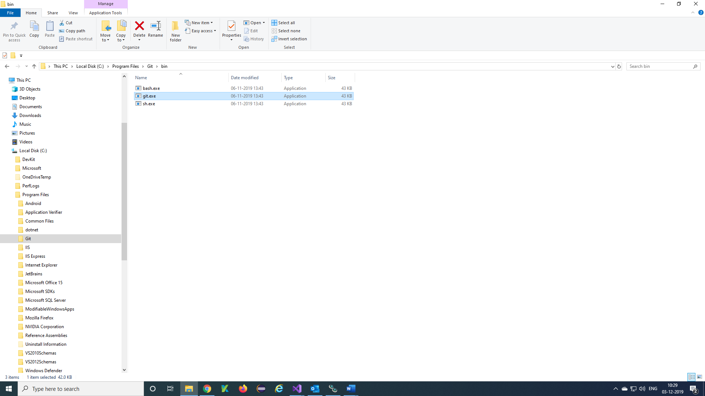

***Path of MSBuild Exe in PC:***

***Step 1)*** Copy the path of MSBuild.exe

C:\Program Files (x86)\Microsoft Visual Studio\2019\Community\MSBuild\Current\Bin

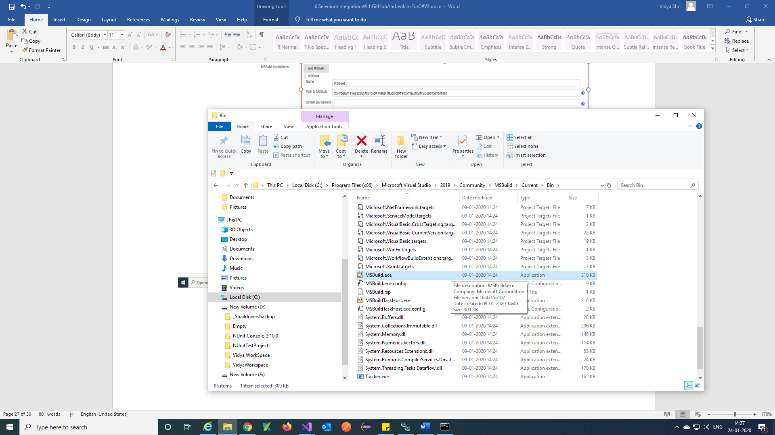

***Download nuget.exe:***

***Step 1)*** Download the nuget.exe using the below link

<https://www.nuget.org/downloads>

Click on nuget.exe v5.3.1 version, nuget.exe will download.

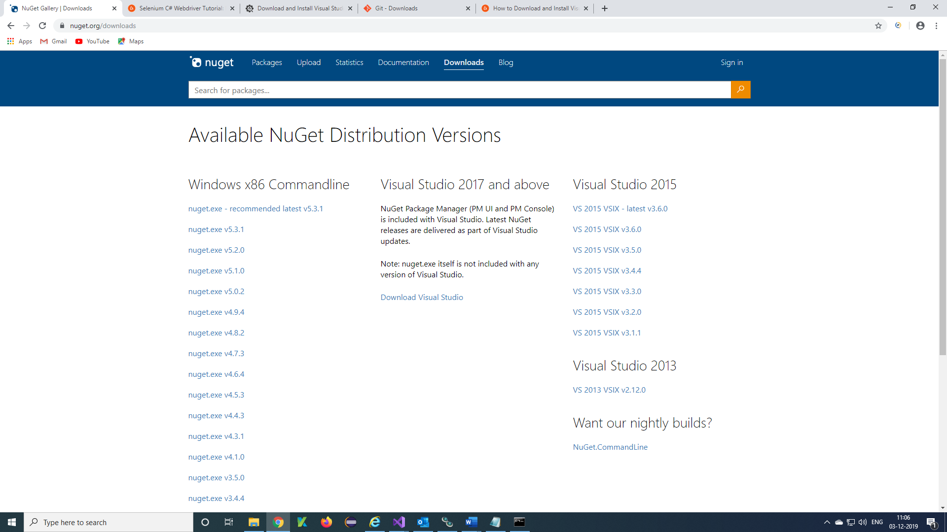

***Step 2)*** Once after downloaded you will get nuget.exe in downloads of PC

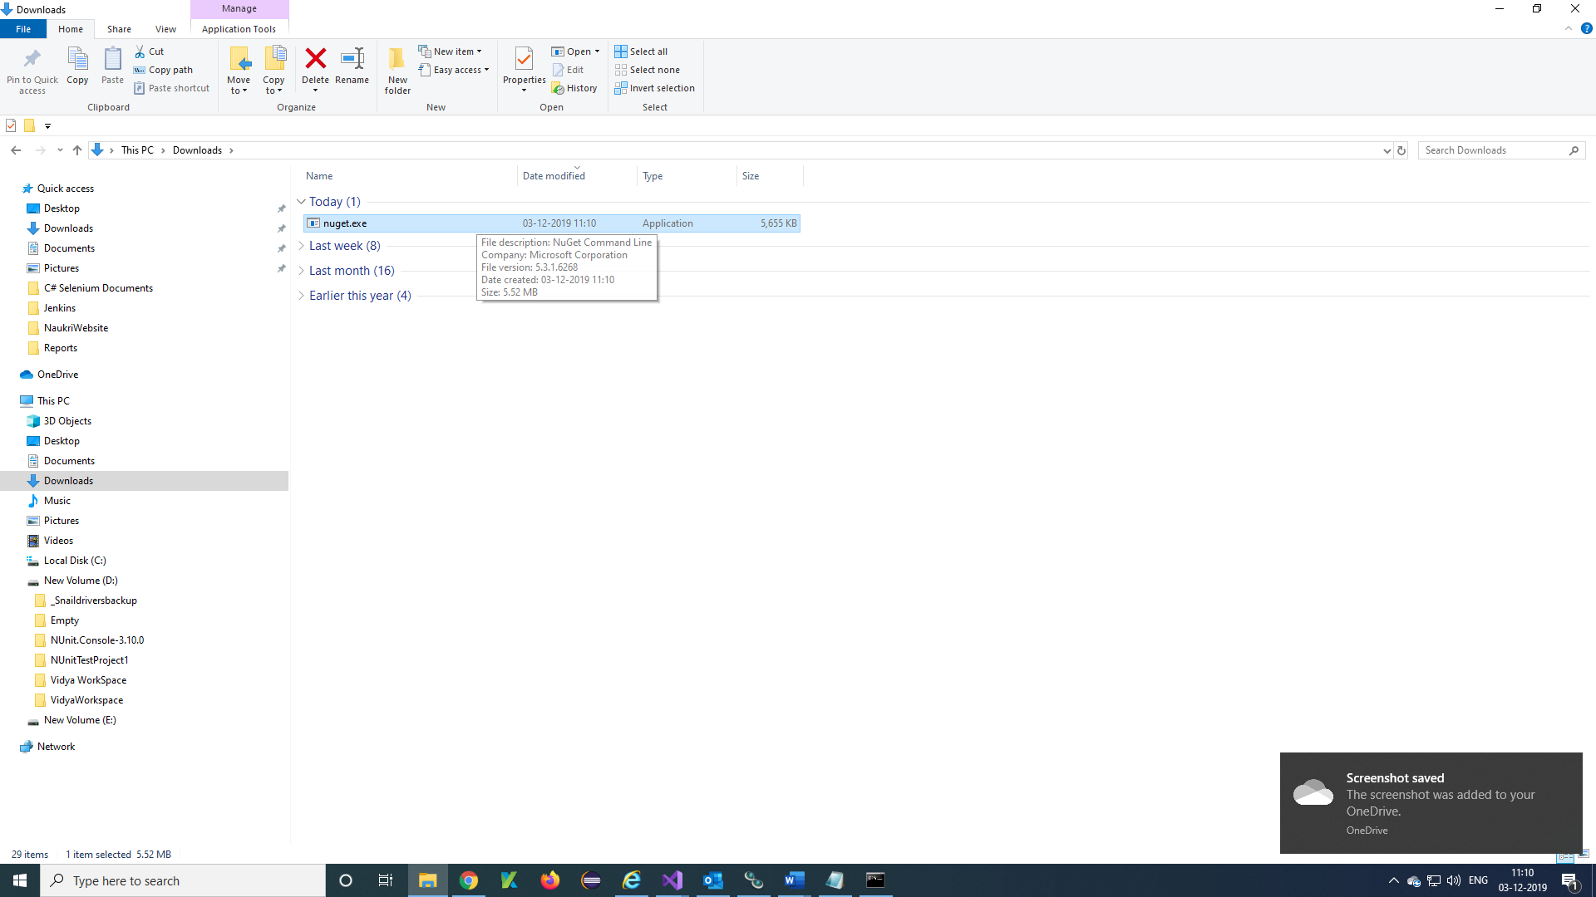

***Step 3)*** Copy and paste the nuget.exe file to your required location and copy the path of exe.

"D:\VidyaWorkspace\Jenkins\nuget.exe"

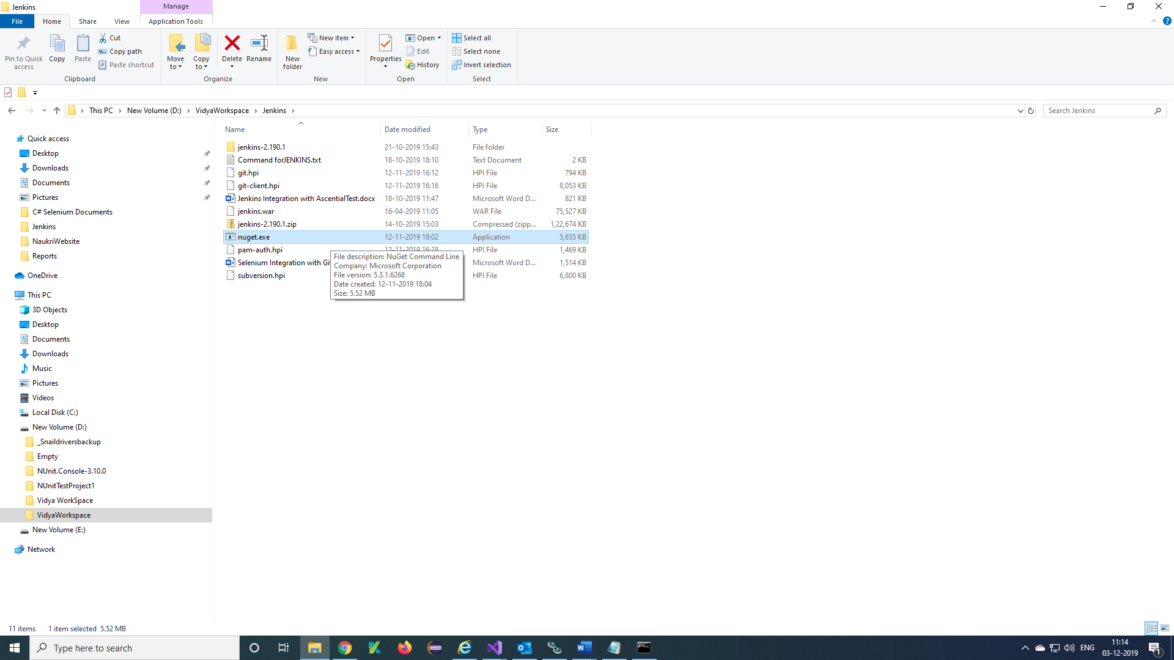

***Download and Set up Nunit Console:***

***Step 1)*** Open browser and download Nunit Console from URL= <https://nunit.org/download/> and Click on Nunit Console 3.10

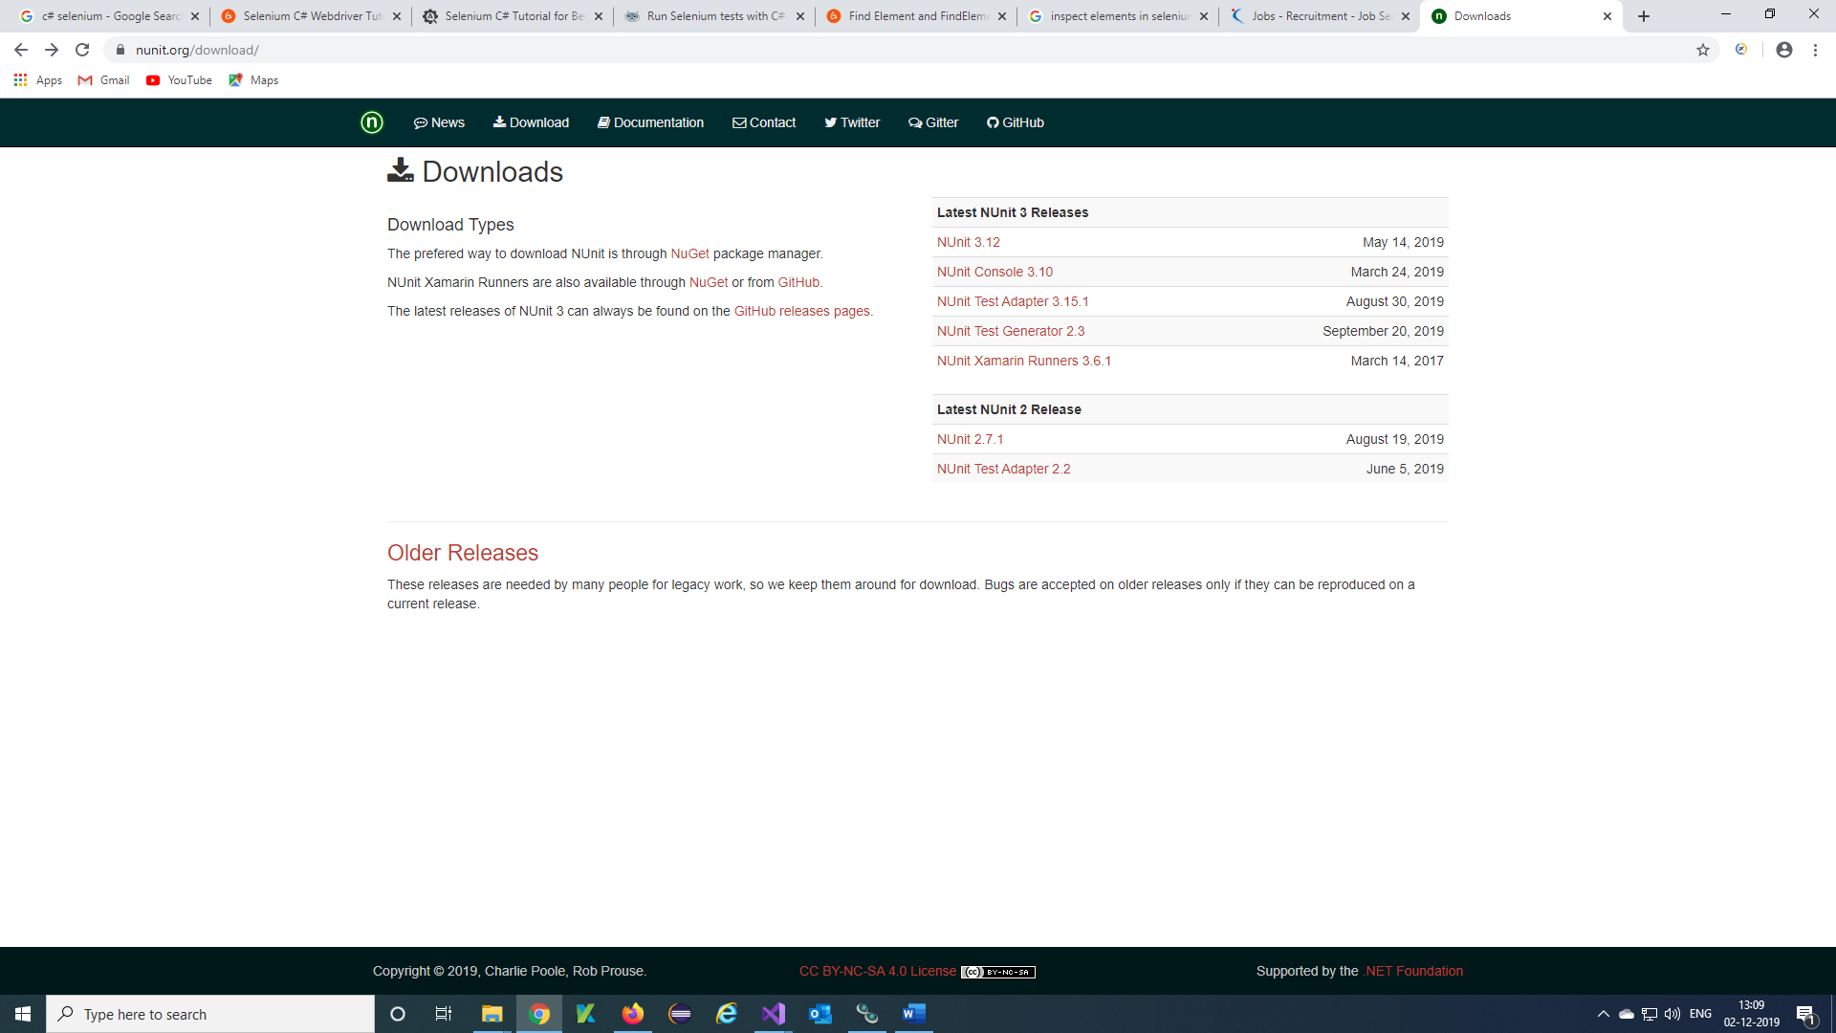

***Step 2)*** Select NUnit.Console.3.10.0.msi

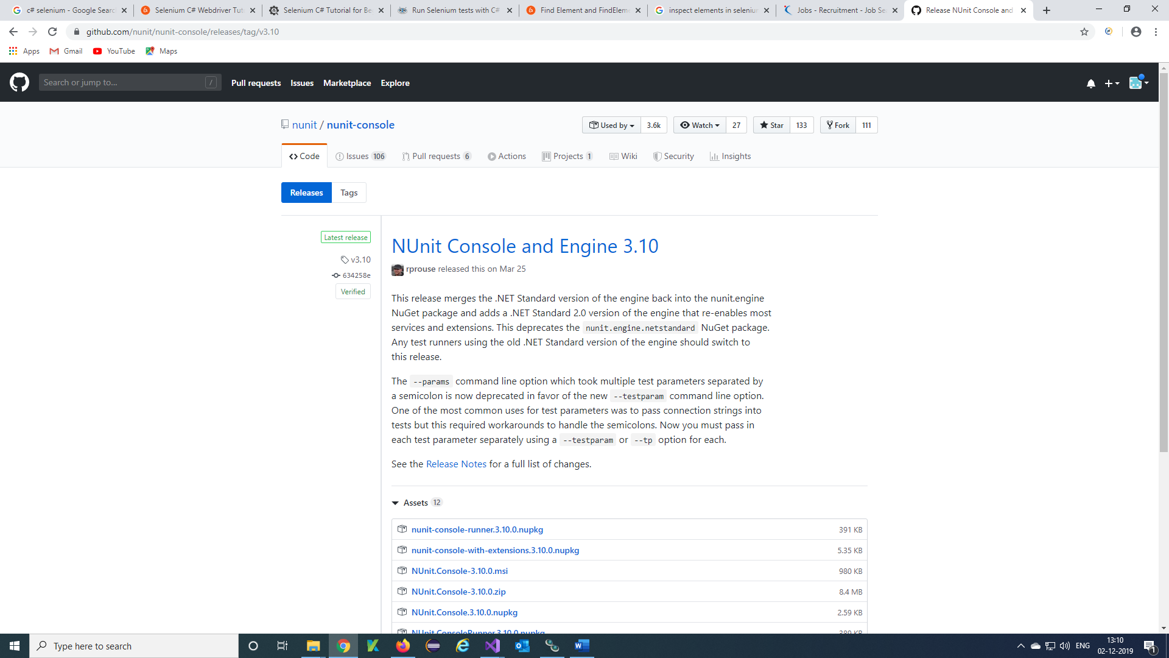

***Step 3)*** Nunit console will downloaded in downloads of your pc.

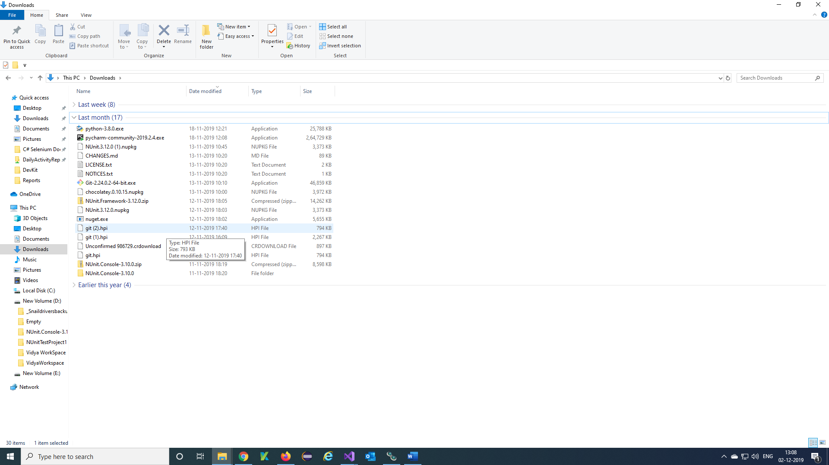

***Step 4)*** Copy and Paste Downloaded Nunit Console to required location and Click on Nunit Console folder

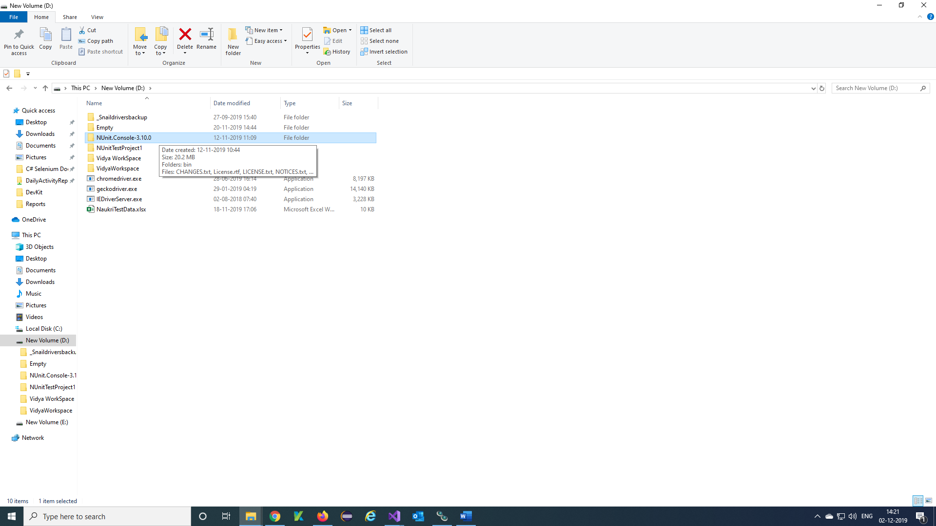

***Step 5)*** Click on bin folder

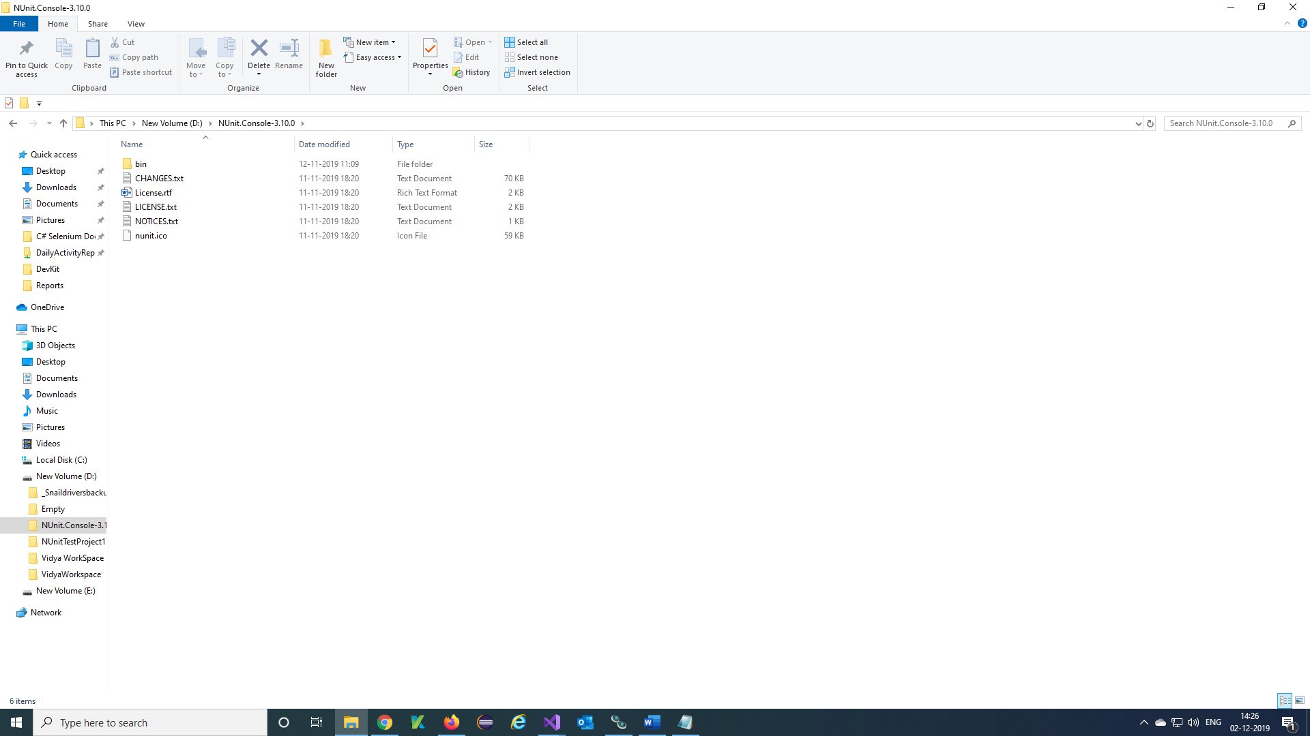

***Step 6)*** Click on net20 folder

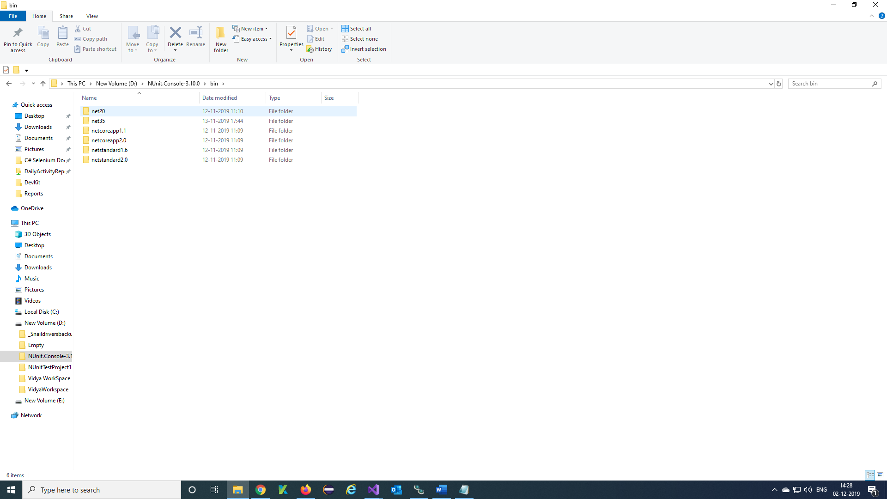

***Step 7)*** nunit3-console.exe will appear, copy the path of the nunit3-console.exe

"D:\VidyaWorkspace\NUnit.Console-3.10.0\bin\net20\nunit3-console.exe"

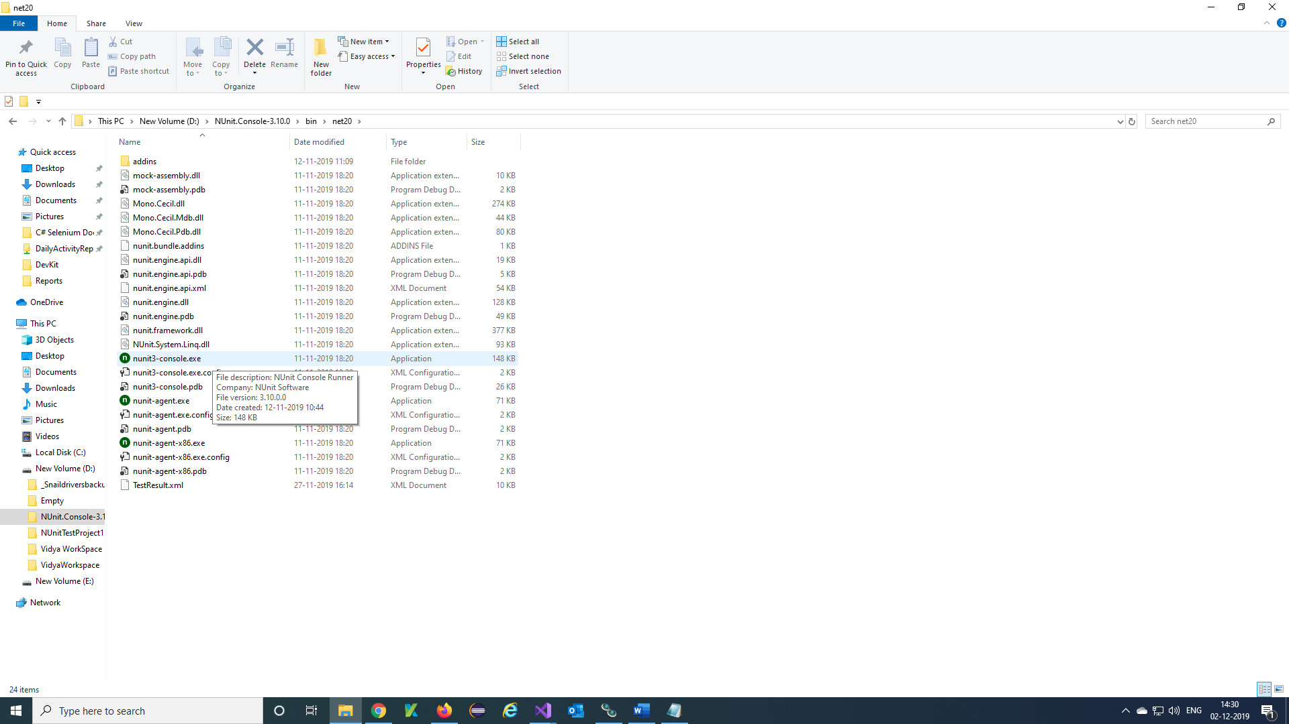

***Set up the Jenkins for Visual Studio Project:***

***Step 1)*** Open browser and download Jenkins war file from URL = <https://jenkins.io/download/>

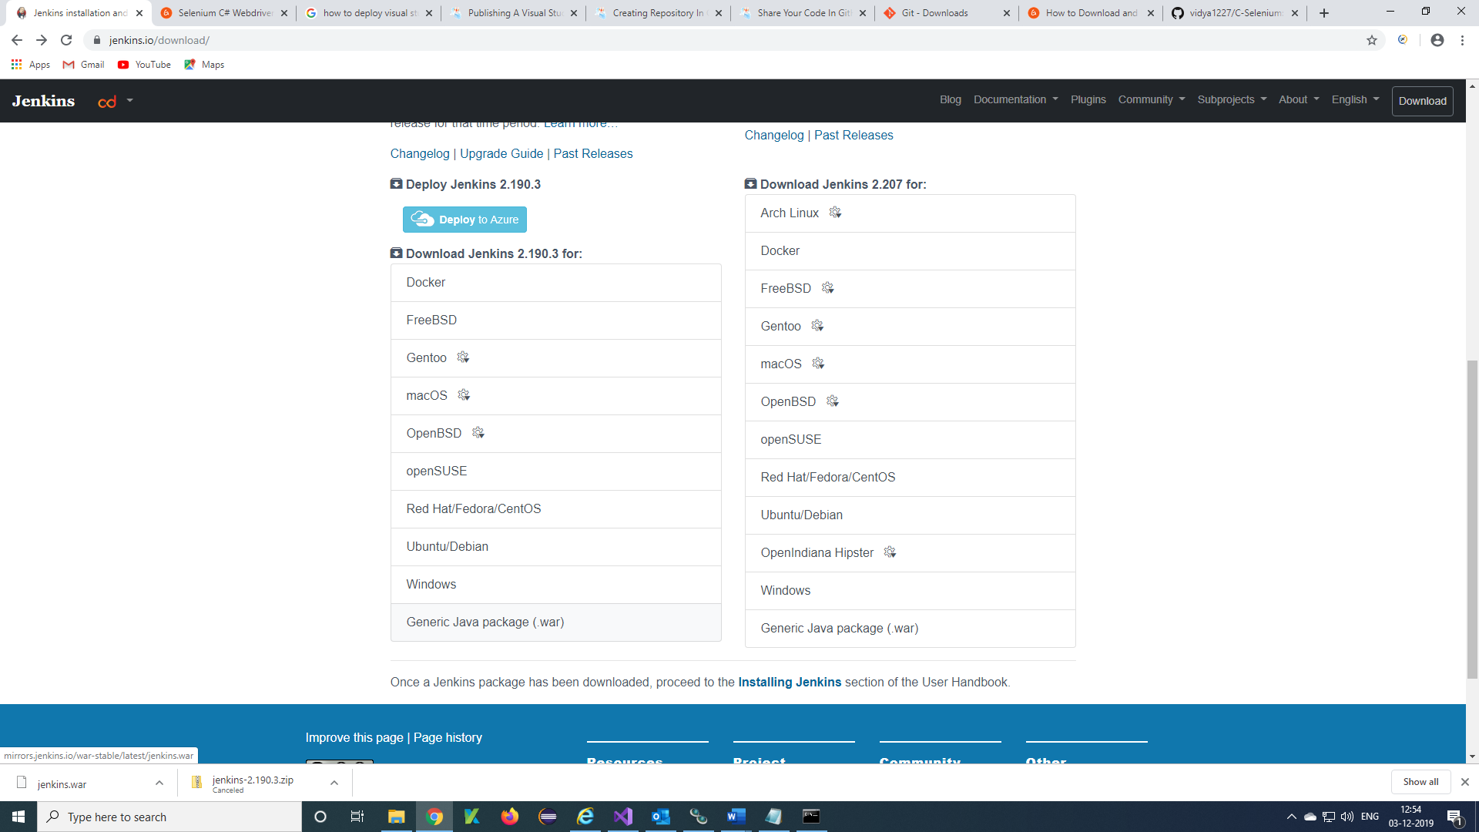

***Step 2)*** Once after downloaded you will get Jenkins.war in downloads of PC

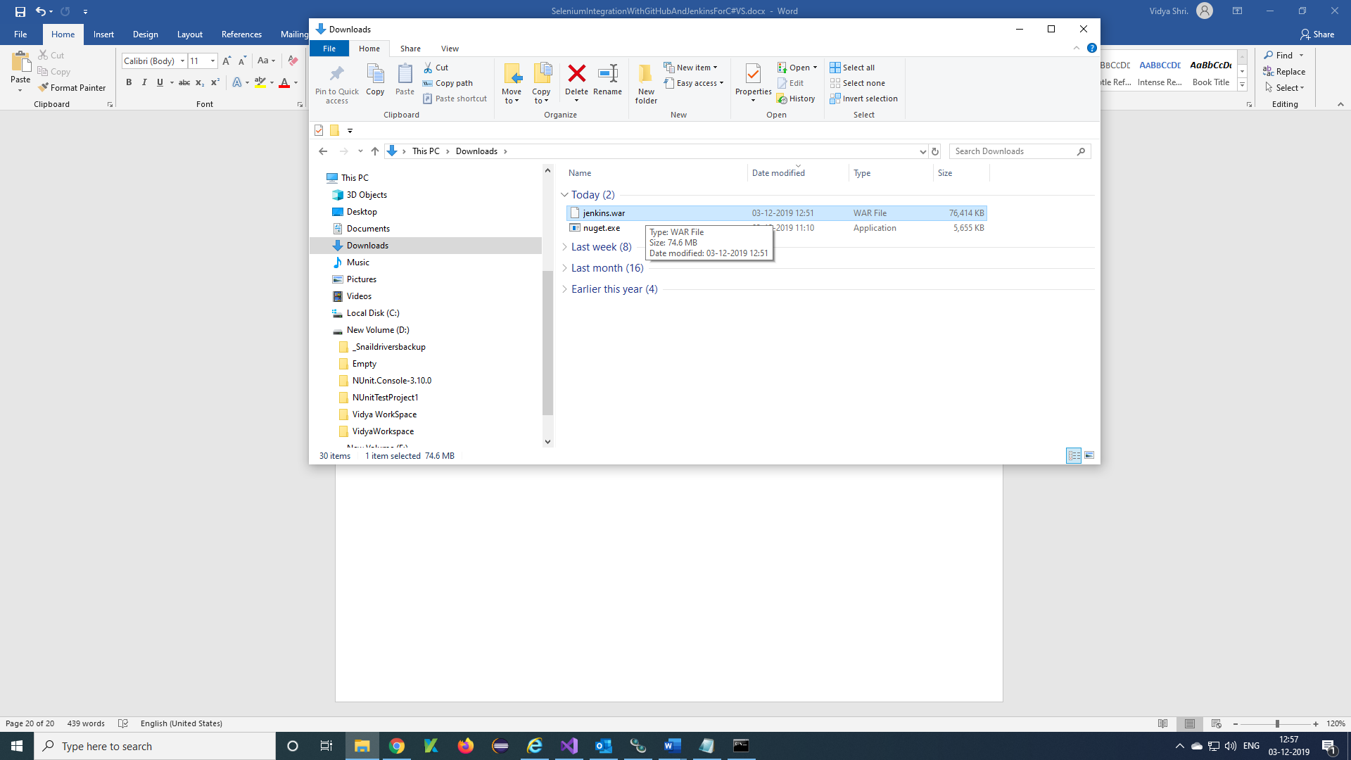

***Step 3)*** Copy and paste the jenkins.war file to your required location

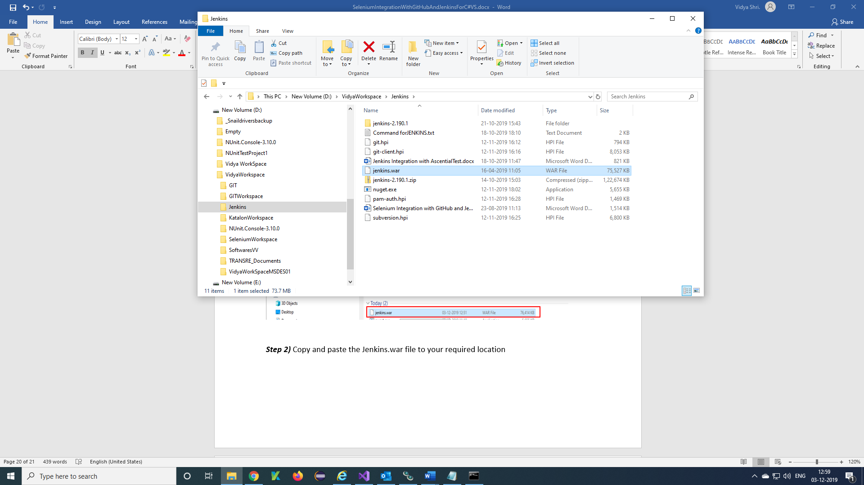

**Step 4)** Deploying command will be

Traverse to the folder location where the jenkins.war file is placed and run the below command in **Java –jar Jenkins.war**

command prompt. If you have not hosted any application on 8080 you can directly give the command as

**Or** to run on different port you can use the below command

**Java –jar Jenkins.war --httpPort=8088**

Once the Jenkins.war file is deployed successfully you can access Jenkins through the below URL.

<http://localhost:8088/>

click on New Item

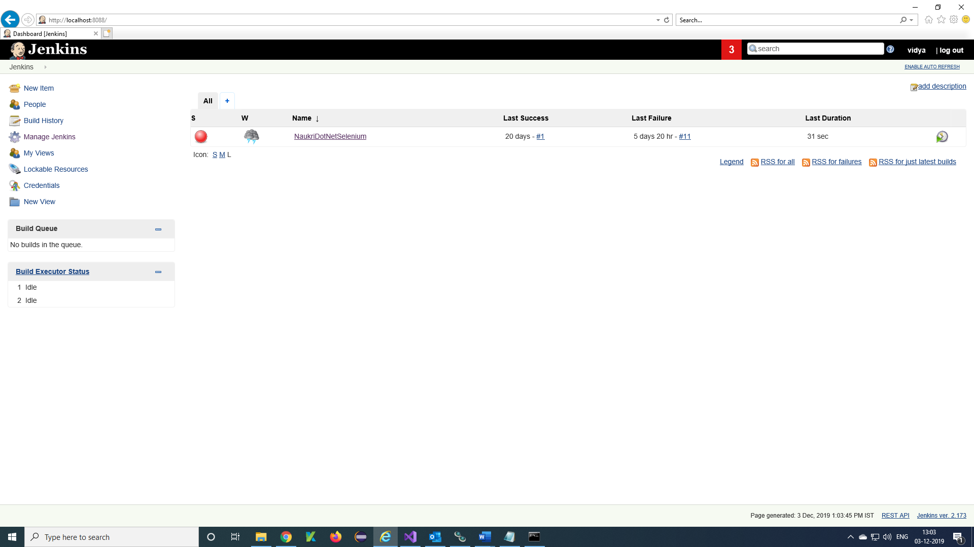

**Step 5)** Select Freestyle project and enter Item name then click on ok

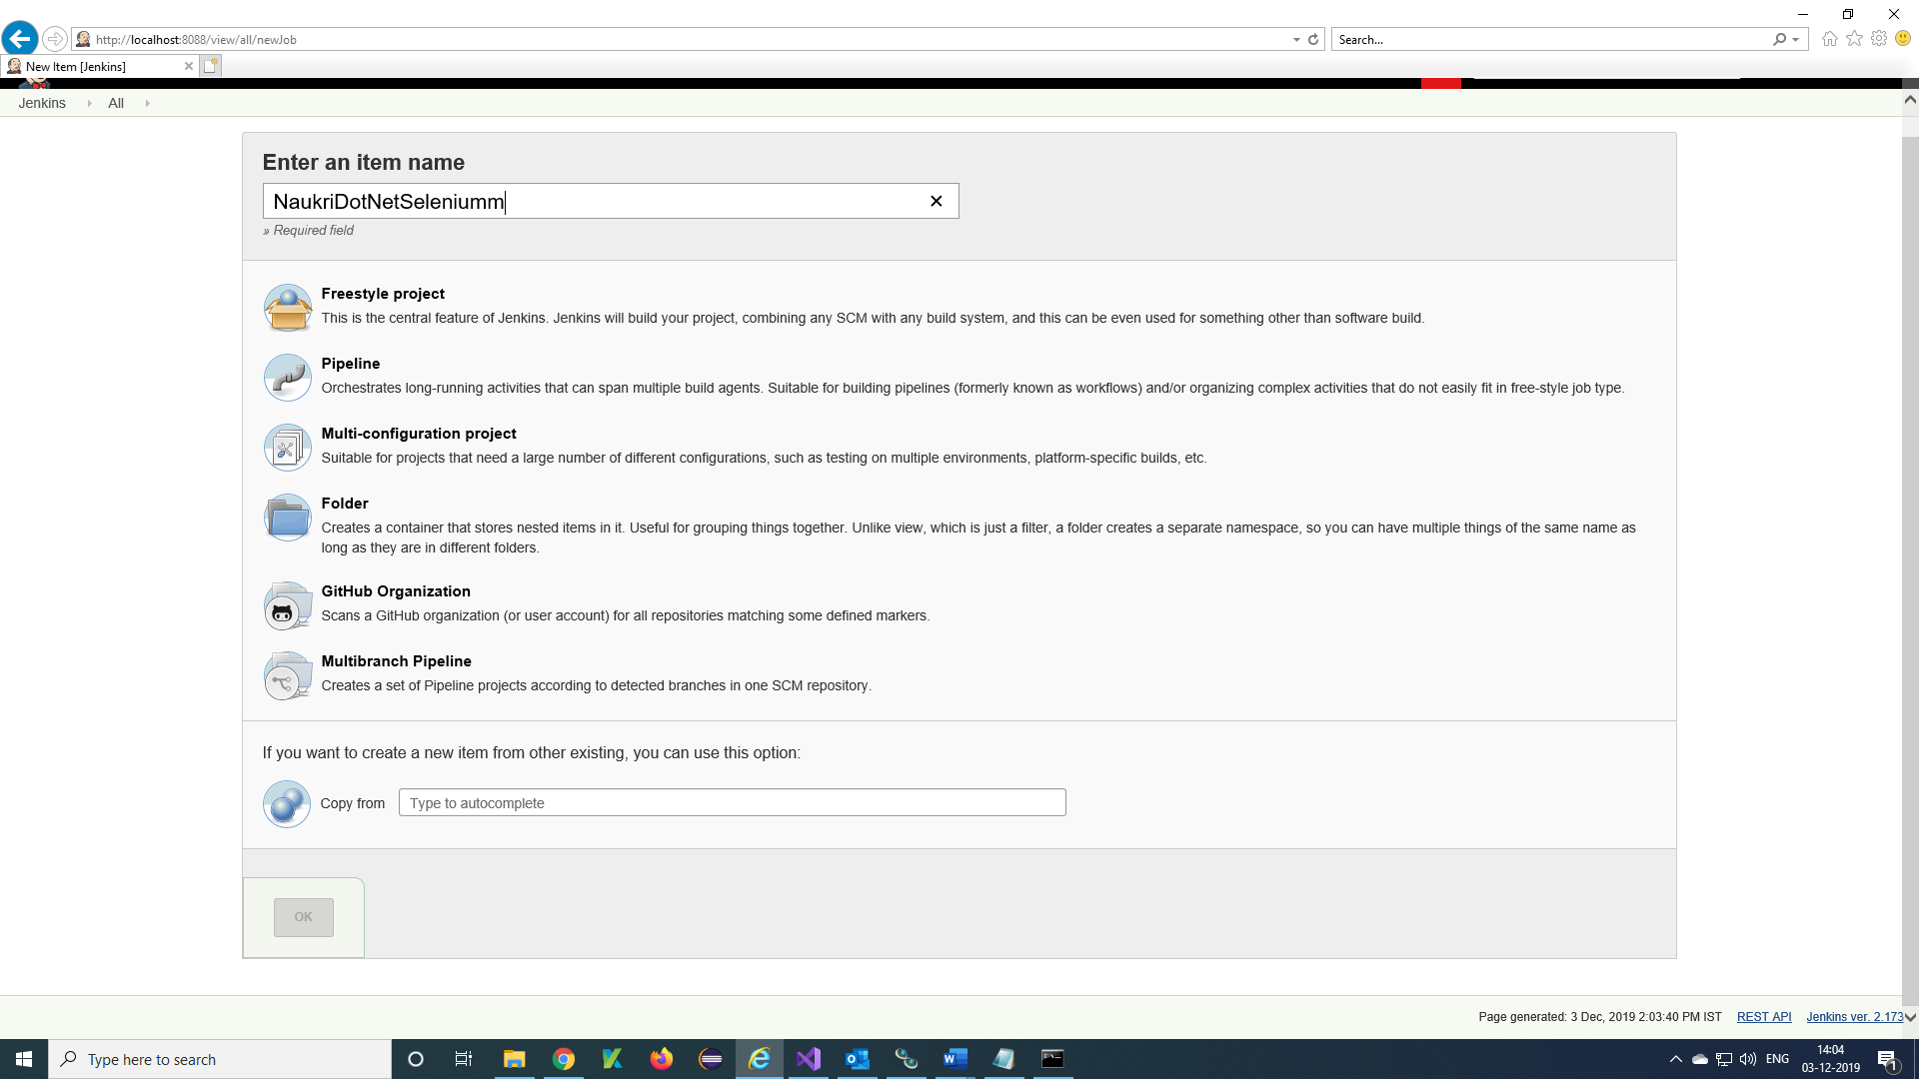

**Step 6)** Project is created and it will display then click on Manage Jenkins

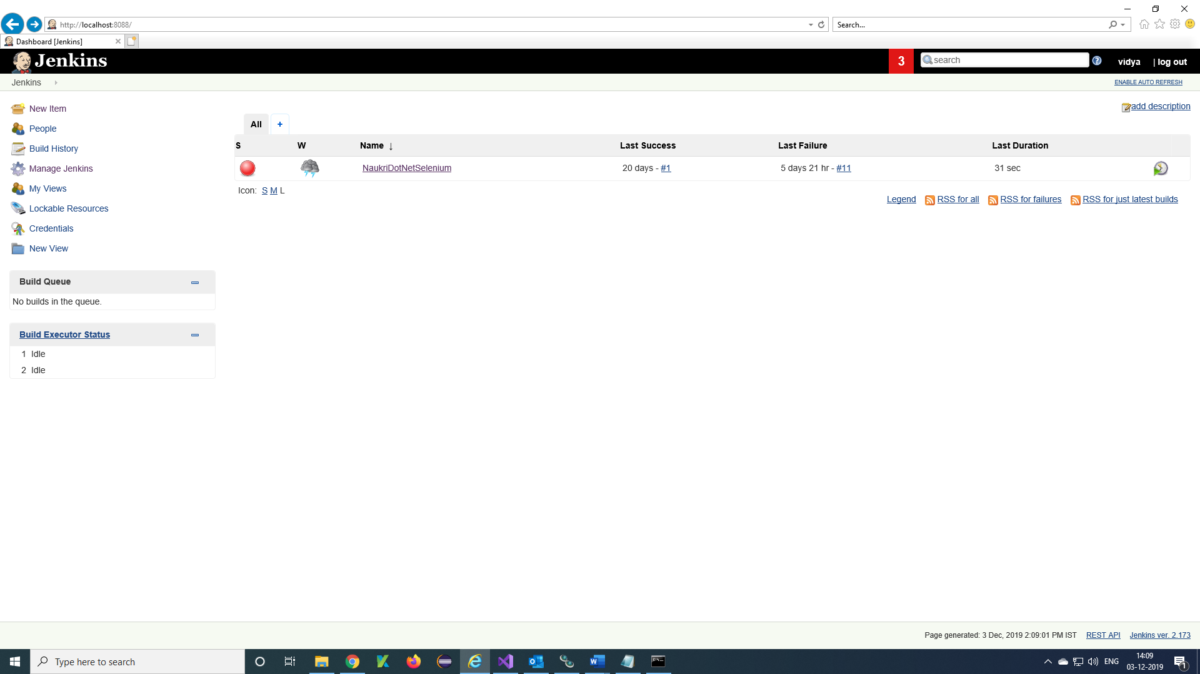

**Step 7)** Click on Global Tool Configuration

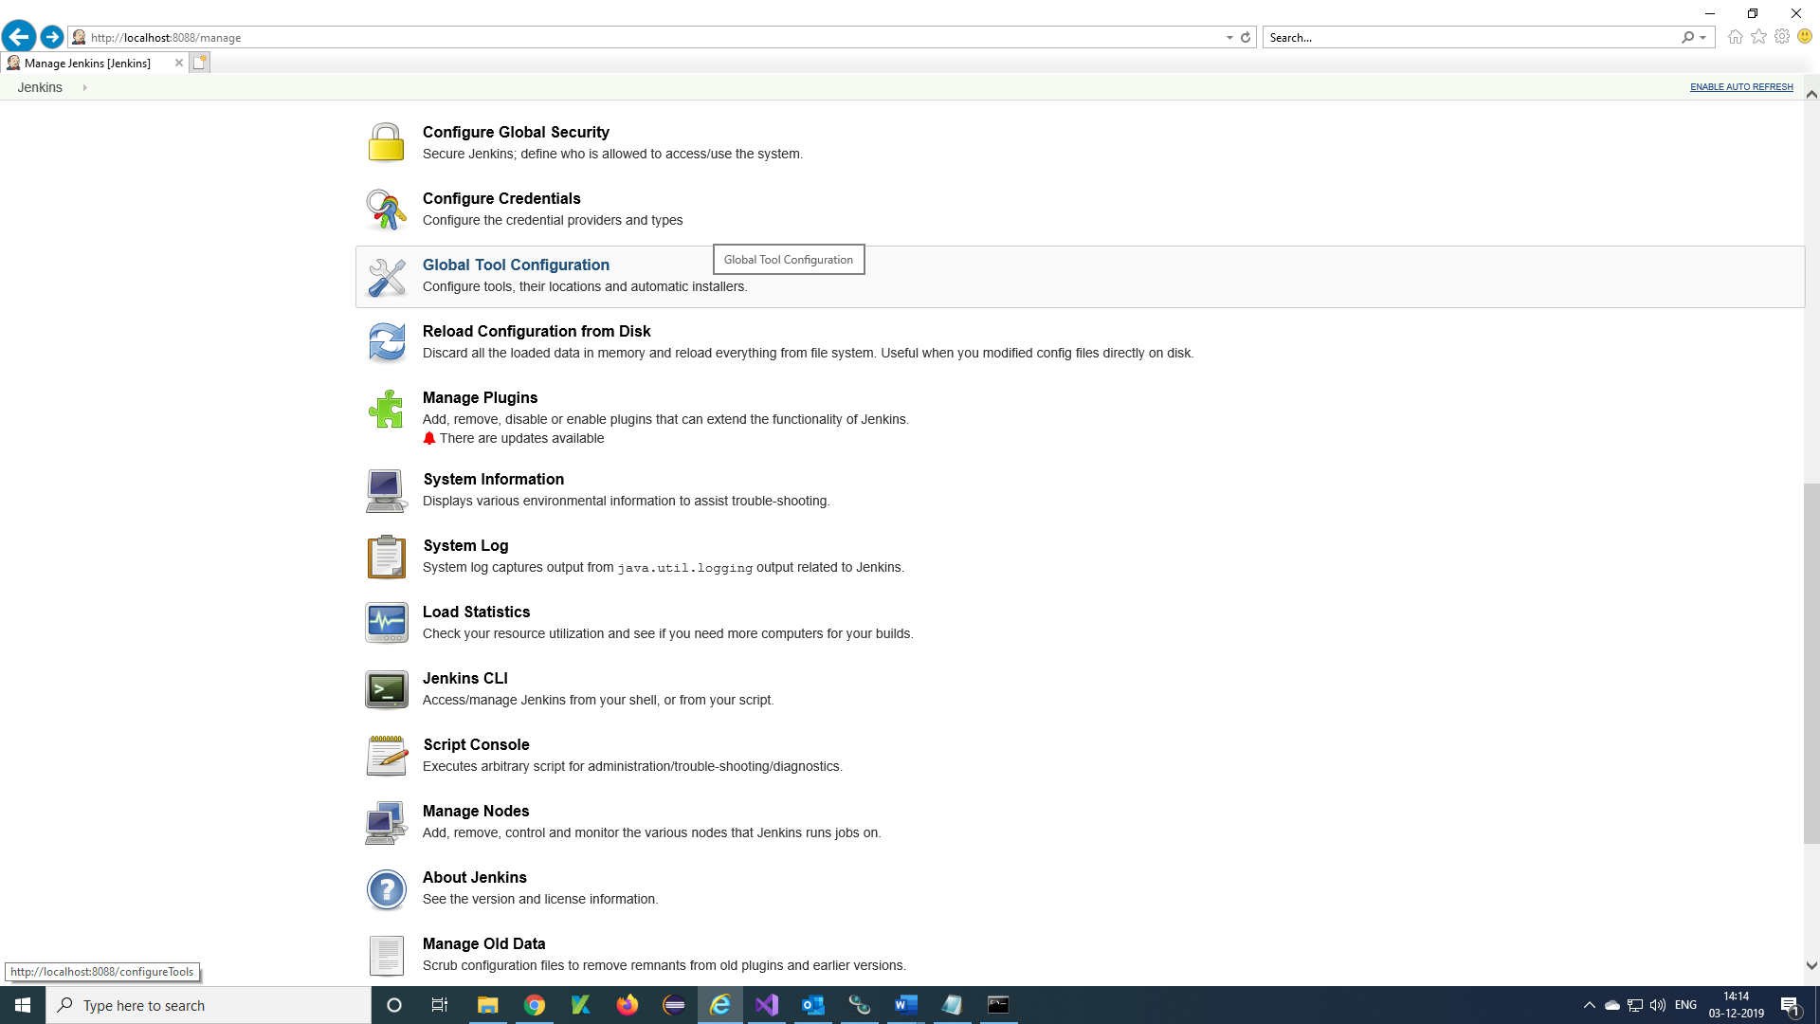

**Step 8)** Set up Git and MSBuild paths 🡪 Apply 🡪 Save

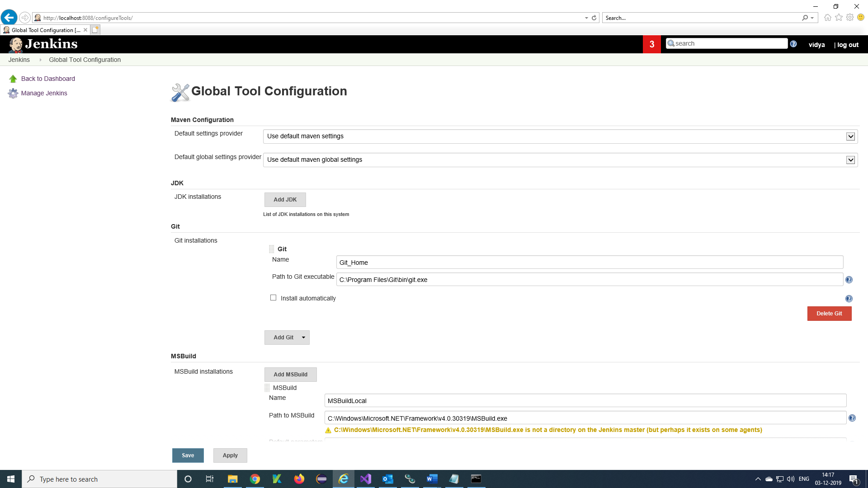

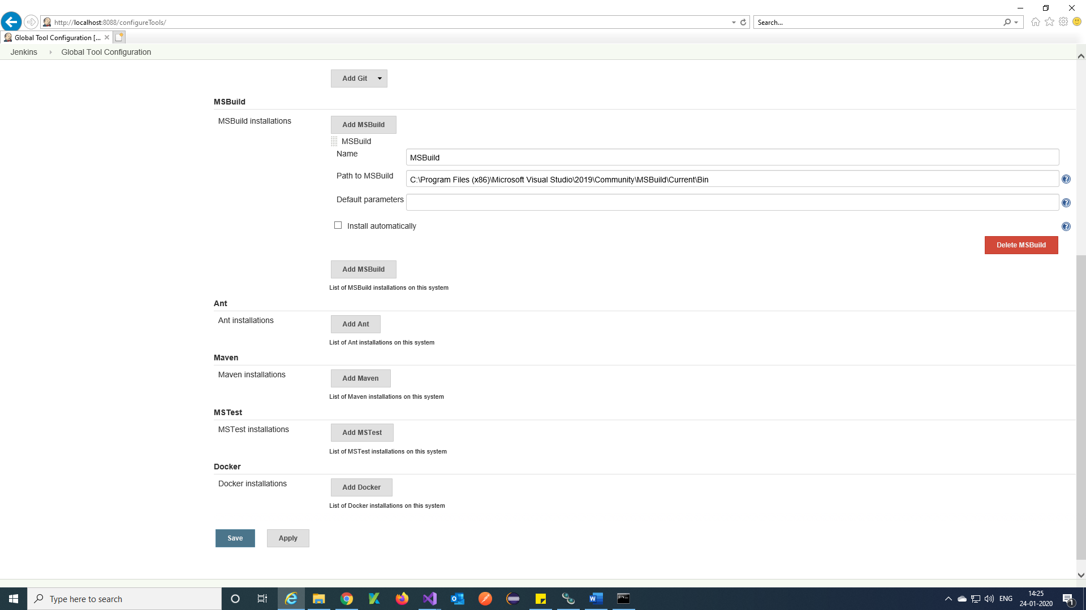

**Step 9)** Open project 🡪 configure

**Step 10)** Select Git as your Source control and Provide the Repository URL: https://github.com/vidya1227/C-Selenium.git copy from GitHub

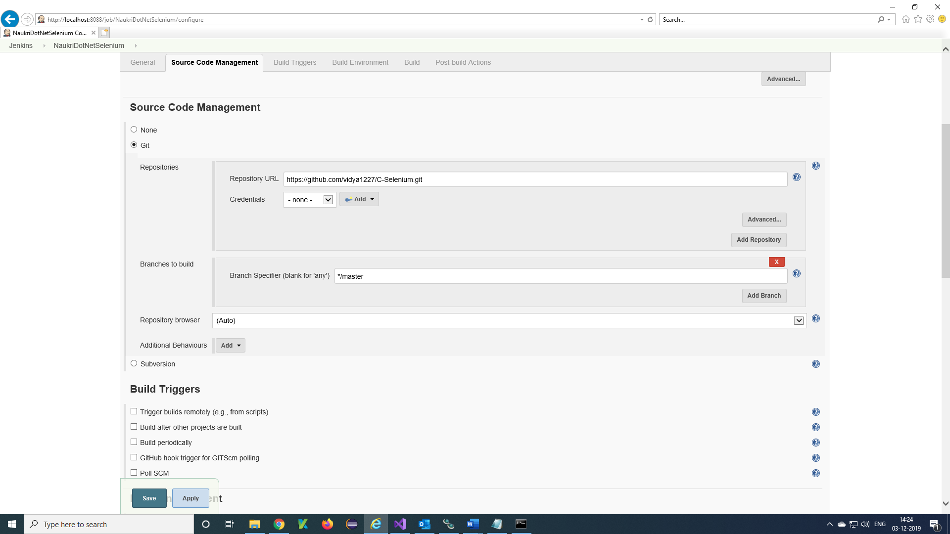

Give the command in Build

"D:\VidyaWorkspace\Jenkins\nuget.exe" restore NaukriWebsiteNUnit3.sln

Call the created MSBuild in Global Tool Configuration

MSBuild Version = MSBuildLocal

Give the Visual Studio Project solution name in MSBuild Build File

MSBuild Build File = NaukriWebsiteNUnit3.sln

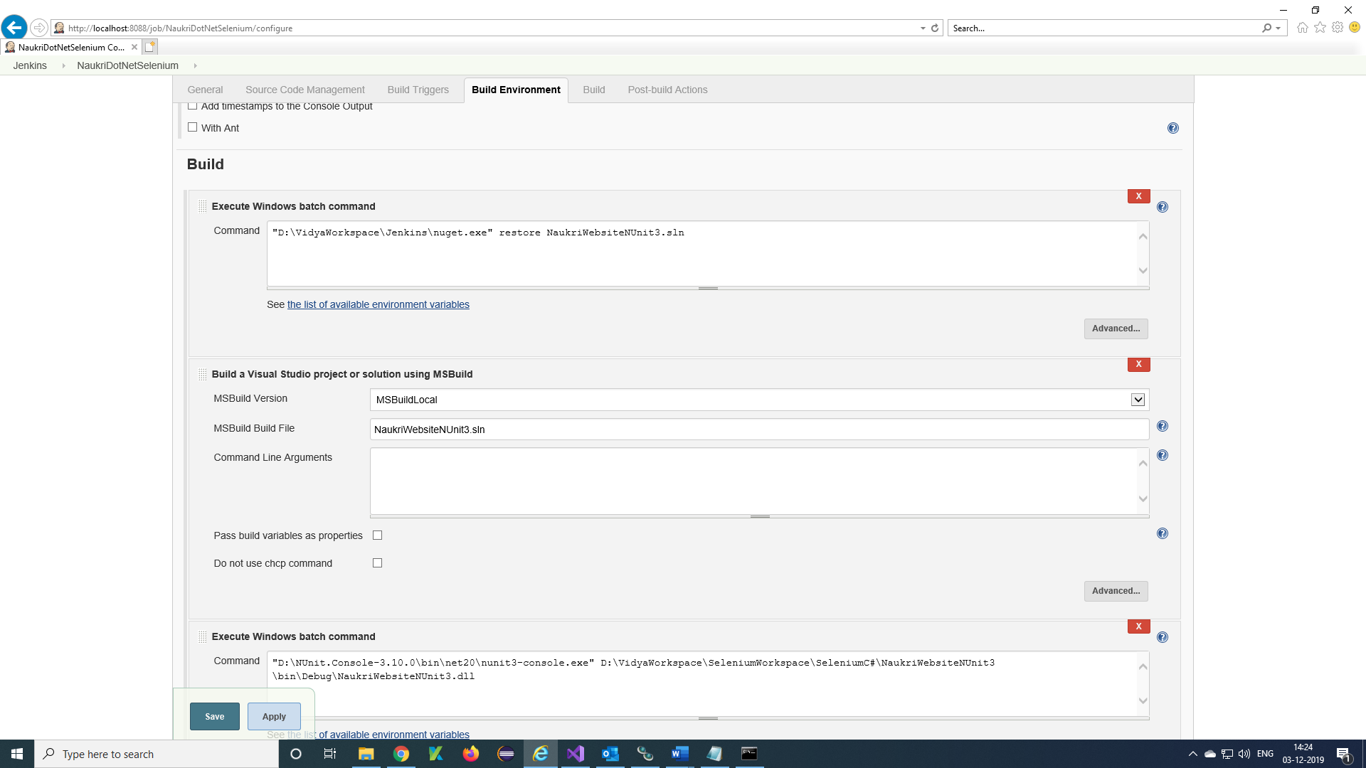

Enter command in Excute Windows batch command

"D:\NUnit.Console-3.10.0\bin\net20\nunit3-console.exe" D:\VidyaWorkspace\SeleniumWorkspace\SeleniumC#\NaukriWebsiteNUnit3\bin\Debug\NaukriWebsiteNUnit3.dll

then Apply 🡪 Save

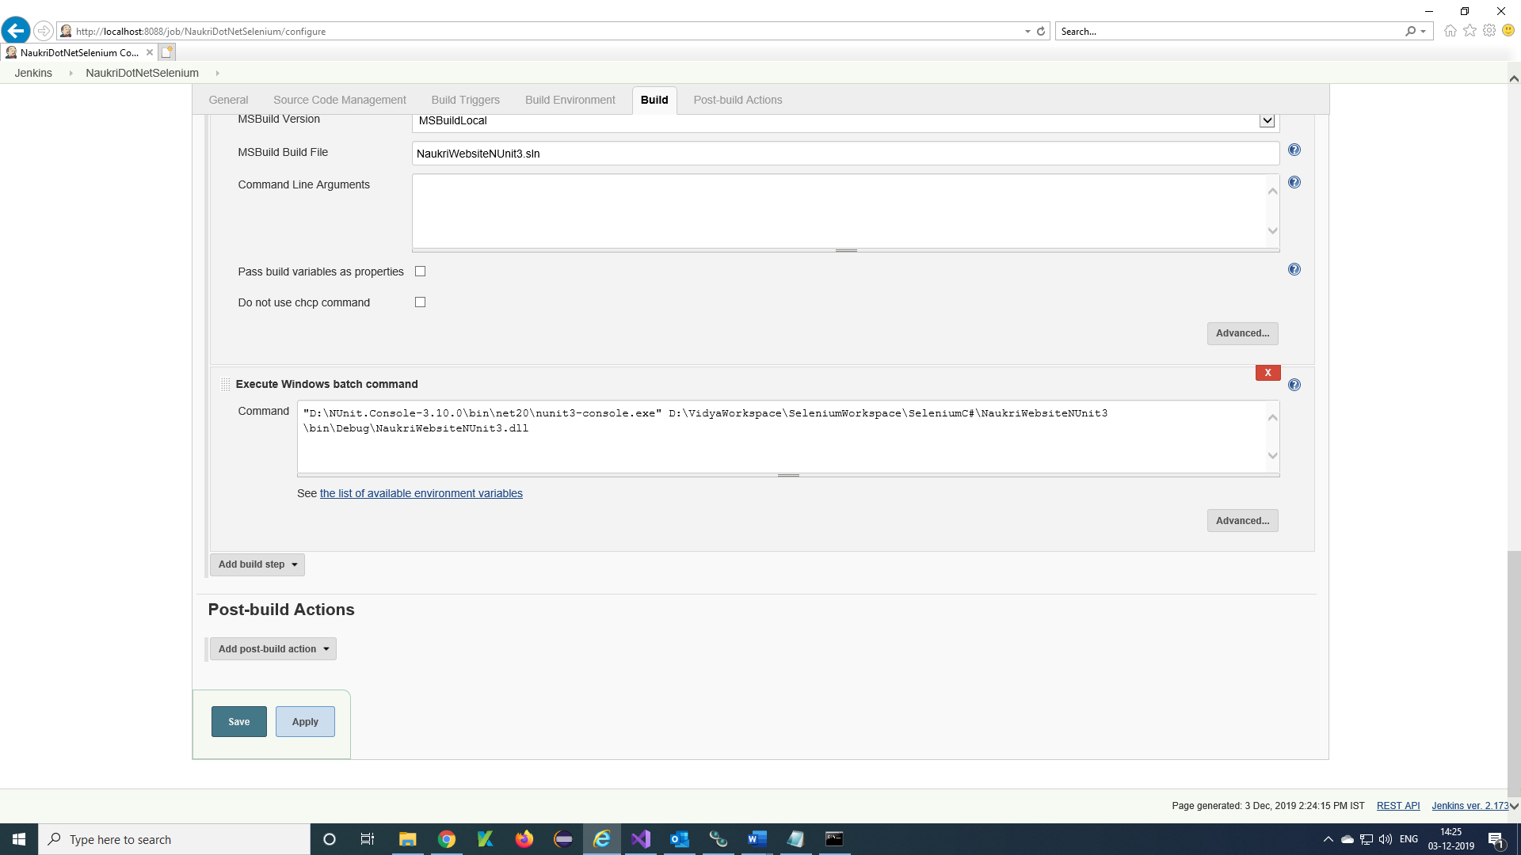

**Note**: 1. Type the command to run single test

nunit3-console.exe "D:\VidyaWorkspace\SeleniumWorkspace\SeleniumC#\ZeenyxWebsite_CSharp\bin\Debug\ZeenyxWebsite_CSharp.dll" /test:ZeenyxWebsite_CSharp.InfoReqTestcase1.Test1

**Syntax:** nunit3-console.exe <Project dll> /test:<NameSpace>.<ClassName>.<testName>

2.Type the command to run Test plan

nunit3-console.exe "D:\VidyaWorkspace\SeleniumWorkspace\SeleniumC#\ZeenyxWebsite_CSharp\bin\Debug\ZeenyxWebsite_CSharp.dll" /test:ZeenyxWebsite_CSharp.TestPlan

**Syntax:** nunit3-console.exe <Project dll> /test:<namespace>.<classname>

**Step 11)** Click on Build Now to run the project

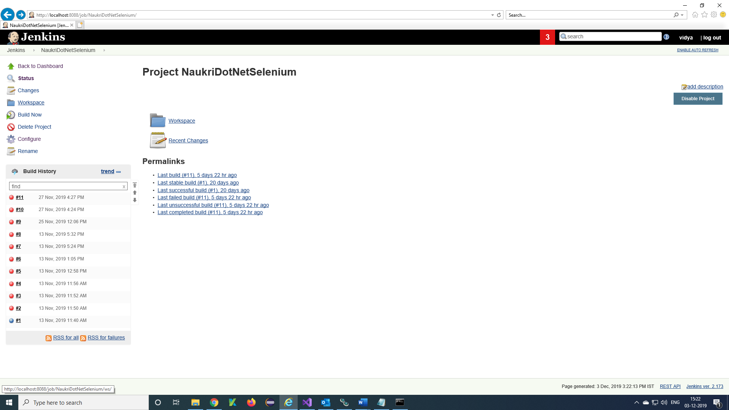

Once the Build is successful you will receive a blue icon in the build history along with the build number, if it is fails means you will get red icon.